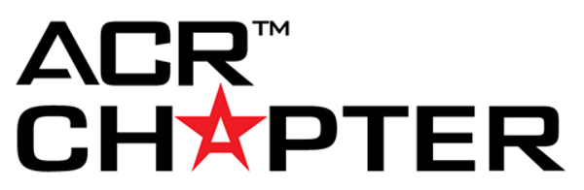

Chapter Recognition: Quality & Safety

Quality & Safety Update
This section allows you to provide an update on how your chapter addressed quality and safety issues in 2021.
1. Did your chapter sponsor educational programs focused on quality improvement or patient safety? (10 points for answering "yes")
☐ Yes
☐ No

2. Did your chapter engage in quality improvement efforts? (10 points for answering "yes")
☐ Yes
☐ No

3. Has your chapter taken the Image Wisely Pledge for Associations to endorse and promote the goals of Image Wisely among members? (10 points for answering "yes")
☐ Yes
☐ No

4. Has your chapter promoted Image Gently campaign among members? (10 points for answering "yes")
☐ Yes
☐ No

5. Has your chapter been involved in patient safety reporting related to systemic data collection, analysis of radiology adverse events, or incidents? (10 points for answering "yes")
☐ Yes
☐ No

6. Has your chapter posted/published resources on patient safety online? (10 points for answering "yes")
☐ Yes
☐ No

7. Has your chapter encouraged members to submit commentary on Practice Parameters & Technical Standards? (10 points for answering "yes")
☐ Yes
☐ No

8. Has your chapter promoted the intended use of Practice Parameters & Technical Standards? (10 points for answering "yes")
☐ Yes
☐ No

9. Has your chapter promoted knowledge/use of the Contrast Manual? (10 points for answering "yes")
☐ Yes
☐ No

10. Has your chapter promoted knowledge/use of the Appropriateness Criteria? (10 points for answering "yes")
☐ Yes
☐ No

11. Has your chapter engaged in quality and safety initiatives other than the ones listed above in 2021? Name any other quality and safety initiatives below. (10 points per named initiative; 5 max, potential of 50 points total)

Quality & Safety Resources
Describe quality and safety resources developed by the chapter as well as the method(s) of distribution.
1. Name any quality and safety resource(s) your chapter created in 2021. (10 points for answering this question)

2. Describe why the resource(s) were created and how they were distributed. (10 points for answering this question)

Radiation Safety Initiatives
Describe chapter efforts to raise radiation safety awareness.
- Name any radiation safety initiatives your chapter designed and implemented in 2021. (10 points for answering this question)

2. Describe why each safety initiative was created and dissemination efforts. (10 points for answering this question)

Support of National Quality & Safety Initiatives
Explain chapter efforts to support national quality and safety initiatives.
How did the chapter support national quality and safety initiatives in 2021? (Answering this question earns 20 points)

