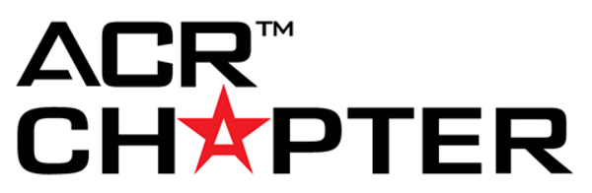

Chapter Recognition: Meetings & Education

Executive Committee Meetings Held
Meetings held solely for chapter business and decision-making.
Number of chapter executive meetings held in 2021. (10 points per meeting)

Chapter Meetings Held
Applies to chapter annual, informational, educational or topical meetings held for general members, or specific membership subsets. Meetings may be open to non-members.
Number of chapter meetings held in 2021. (50 points per meeting)

Chapter Meetings Details
Applies to chapter annual, informational, educational or topical meetings held for general members, or specific membership subsets. Meetings may be open to non-members.
1. How many of the meetings included a needs assessment for planning purposes? (10 points per needs assessment)
Click or tap here to enter text.

2. How many of these meetings included a member follow-up survey? (10 points per survey)
Click or tap here to enter text.

3. a) Check any marketing strategy used to promote the meeting(s). (10 points per strategy checked, 10 points for other strategies named below)

YES NO
Email ☐ ☐
Mail ☐ ☐
Chapter Website ☐ ☐
Chapter Publications ☐ ☐
ACR Calendar ☐ ☐
Social Media ☐ ☐
Joint with Other Organization(s) ☐ ☐
Other ☐ ☐
3. b) Name other marketing strategy used. (10 points per strategy named; 5 max, potential of 50 points total)
Click or tap here to enter text.

Chapter Meeting Speakers
Applies to chapter annual, informational, educational or topical meetings held for general members or specific membership subsets. Meetings may be open to non-members.
1. Did you participate in the ACR Chapter Visitation Program in order to have an ACR leader speak at your meeting? (10 points for answering "yes")
☐ Yes
☐ No

2. a) Were there other ACR speakers hosted who were not part of the Speaker Visitation program (RLI speakers or direct speaker invite paid for by the chapter)? (5 points for answering "yes")
☐ Yes
☐ No

2. b) If your chapter had other ACR speakers who were NOT part of the Speaker Visitation Program (RLI speakers or direct speaker invite paid for by the chapter), list those speaker names. (5 points per speaker)

Chapter Meeting Materials and Resources
Applies to chapter annual, informational, educational or topical meetings held for general members or specifics membership subsets. Meetings may be open to non-members.

1. a) What materials were developed for meetings in 2021? (Check all that apply: 10 points for each type of material developed, 10 points per other type of material listed)
YES NO
Meeting Apps ☐ ☐
Marketing Materials ☐ ☐
Slide Presentations ☐ ☐
Videos ☐ ☐
Meeting Program/Agenda ☐ ☐
Presentation Handouts ☐ ☐
Educational Resources ☐ ☐
Other ☐ ☐
1. b) List other materials that were developed for the meeting(s). (10 points per other item listed; 5 max, potential of 50 points total)

Annual Chapter CME
Applies to chapter annual, informational, educational or topical meetings held for general members or specific membership subsets. Meetings may be open to non-members.

How many total CME credits were offered at ALL of your 2021 meetings combined? (10 points per CME credit)
Click or tap here to enter text.

