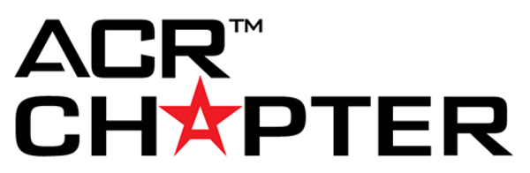

Chapter Recognition: Government Relations

Government Relations Update

1. Does your chapter have a government relations committee (10 points for checking "yes"):
☐ Yes
☐ No

2. Does your chapter have a political action committee for state legislative purposes? (10 points for checking "yes"):
☐ Yes
☐ No

3. Has your chapter hired a lobbyist? (10 points for checking "yes"):
☐ Yes
☐ No

4. Did your chapter invite a member of Congress to attend a chapter meeting in 2021? (10 points for checking "yes"):
☐ Yes
☐ No

5. Did your chapter invite a member of Congress to visit one of your chapter's radiology practices in 2021? (10 points for checking "yes"):
☐ Yes
☐ No

Government Relations Communications

1. In 2021, did the chapter communicate government relations issues to all members? (10 points for answering "yes")
☐ Yes
☐ No

2. a) In 2021, what ways did the chapter communicate government relations issues? (10 points per checked item, 10 points per other effort named)

YES NO
Emails ☐ ☐
Website ☐ ☐
Action Alerts ☐ ☐
Social Media Outreach ☐ ☐
Chapter Meeting Presentations ☐ ☐

2. b) Name any "other" effort(s): (10 points per effort named; 5 max, potential of 50 points total):

Government Relations Presentations at Meetings

On your meeting agenda(s) for chapter meetings and/or board meetings, how many presentations were given on government relations topics? (10 points per presentation; 5 max, potential of 50 points total)
Click or tap here to enter text.

Report on Legislative Testimony

How many individuals from your chapter provided legislative testimony (oral or written) during 2021? (10 points per person; 5 max, potential of 50 points total)

Click or tap here to enter text.

Legislative and Regulatory Issue

1. How many legislative and regulatory issues did the chapter lobby for or against in 2021? (10 points per issue)

Click or tap here to enter text.

2. a) Check all the strategies that the chapter used during lobbying efforts: (10 points per strategy checked, 10 pointed for other efforts named)

YES NO

Email Campaign ☐ ☐

Letter Writing ☐ ☐

Met with Legislator ☐ ☐

Provided Testimony ☐ ☐

Social Media ☐ ☐

Other ☐ ☐

2. b) Name "other" strategies: (10 points per effort named; 5 max, potential of 50 points total)

Legislative Advocacy Day

1. How many Legislative Advocacy Days were held in 2021? (10 points per advocacy day)

Click or tap here to enter text.

2. How many total legislators/legislative staff did your chapter meet with during Legislative Advocacy Days in 2021? (10 points per meeting with legislator/legislative staff)

Click or tap here to enter text.

3. What were the major issue(s) chapter members focused on during Legislative Advocacy Day(s)? (10 points for answering this question)

