Slide 1: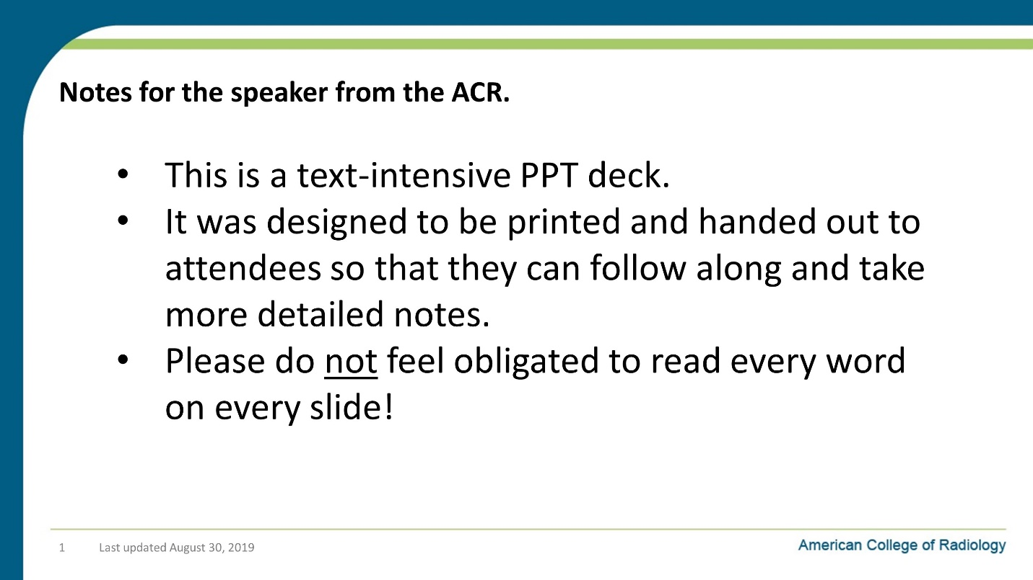

Notes on Slide 1:
Slide 2: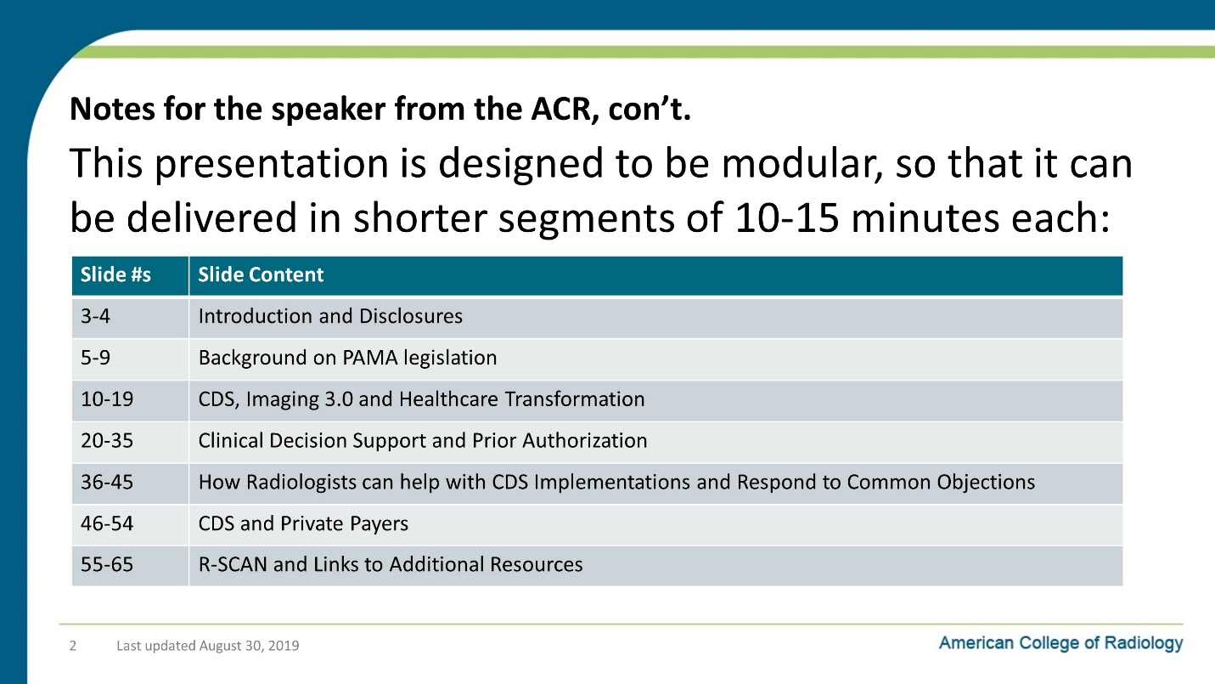

Notes on Slide 2:
Slide 3: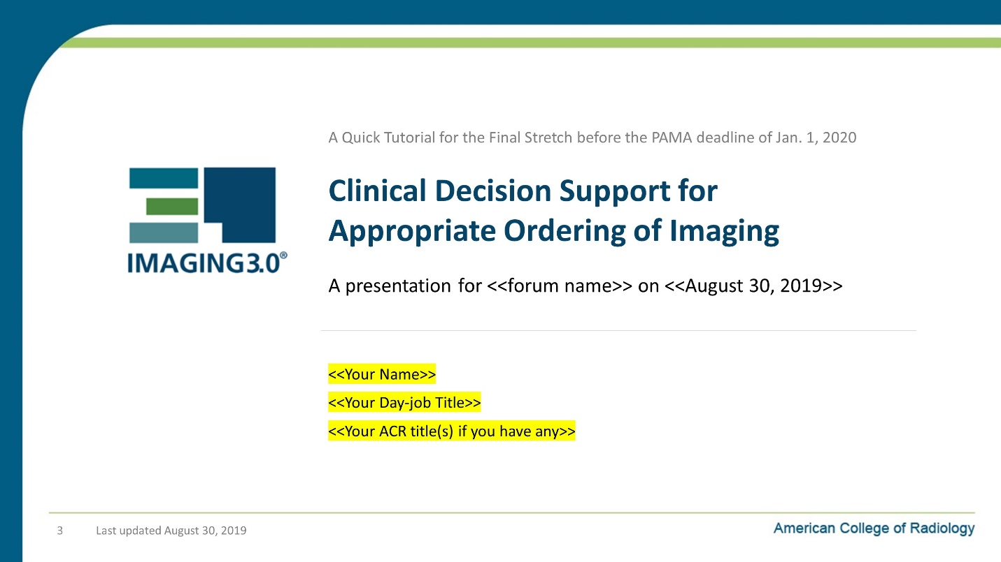

Notes on Slide 3:
Slide 4: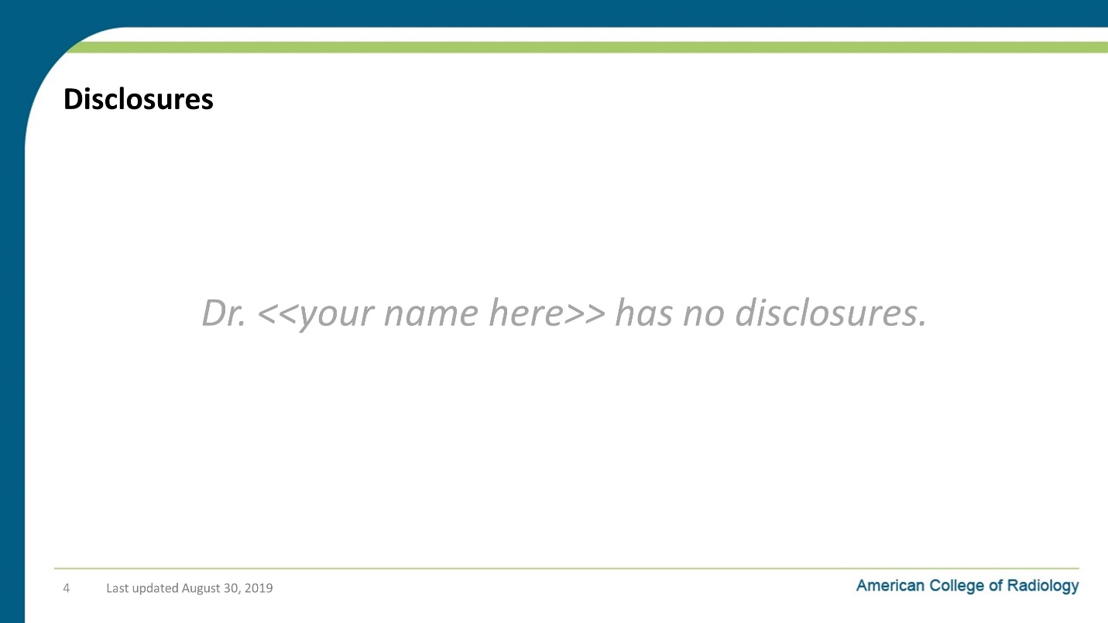

Notes on Slide 4:
My other disclosures are…. <if you have any>.
Or
I have no disclosures to make today.

Slide 5: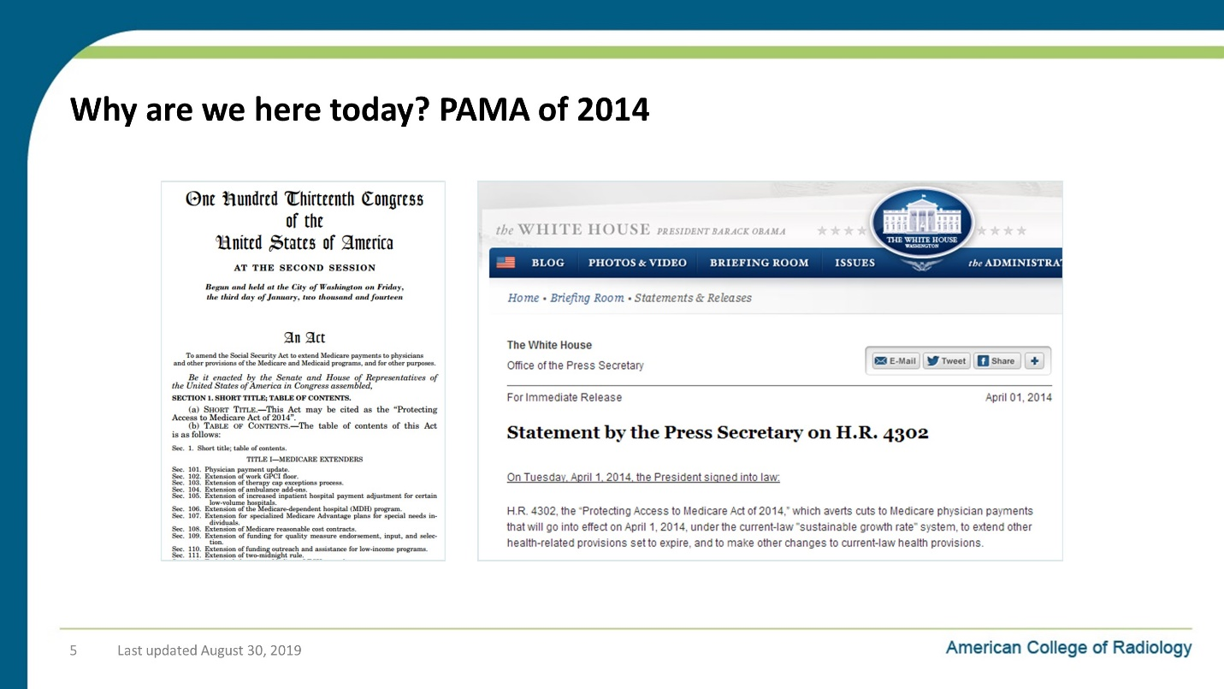

Notes on Slide 5:
In 2014, President Obama signed H.R. 4302 into law.
- It mandated a change that for all Medicare patients needing advanced imaging care (CT, MRI, PET)
    - Physicians will only be paid for advanced imaging exams if the examination was ordered through an approved clinical decision support tool.
    - For those who don’t consult CDS, the alternative will be a new preauthorization process similar to what we have seen for years with private payers.
PAMA was a success for our patients and our specialty b/c:
- It improves care by leveraging the ACR Appropriateness Criteria (AC) and its digital counterpart that can be embedded in an EHR’s ordering workflow
- It kept Medicare from adopted prior authorization and radiology benefits managers for imaging
  - Previously, MedPAC and two presidential administrations recommended to CMS that Medicare use radiology benefits management (RBM) preauthorization (in addition to imaging cuts).
  - The Trump Administration is now targeting all services vulnerable to overutilization with prior authorization and outlier policies.
  - But because of PAMA, diagnostic imaging will not be included in these broad-based cuts.

Slide 6: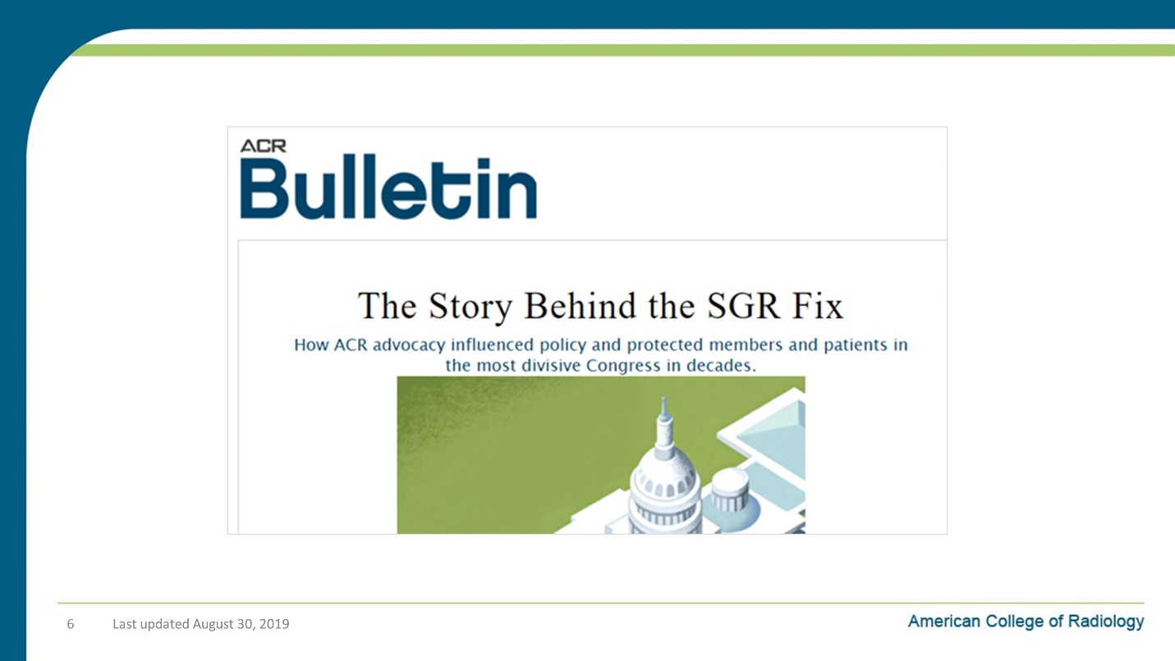

Notes on Slide 6:
Finally, the bill provided a permanent fix to SGR formula problem that had dogged us on Medicare reimbursement for some time.

Slide 7: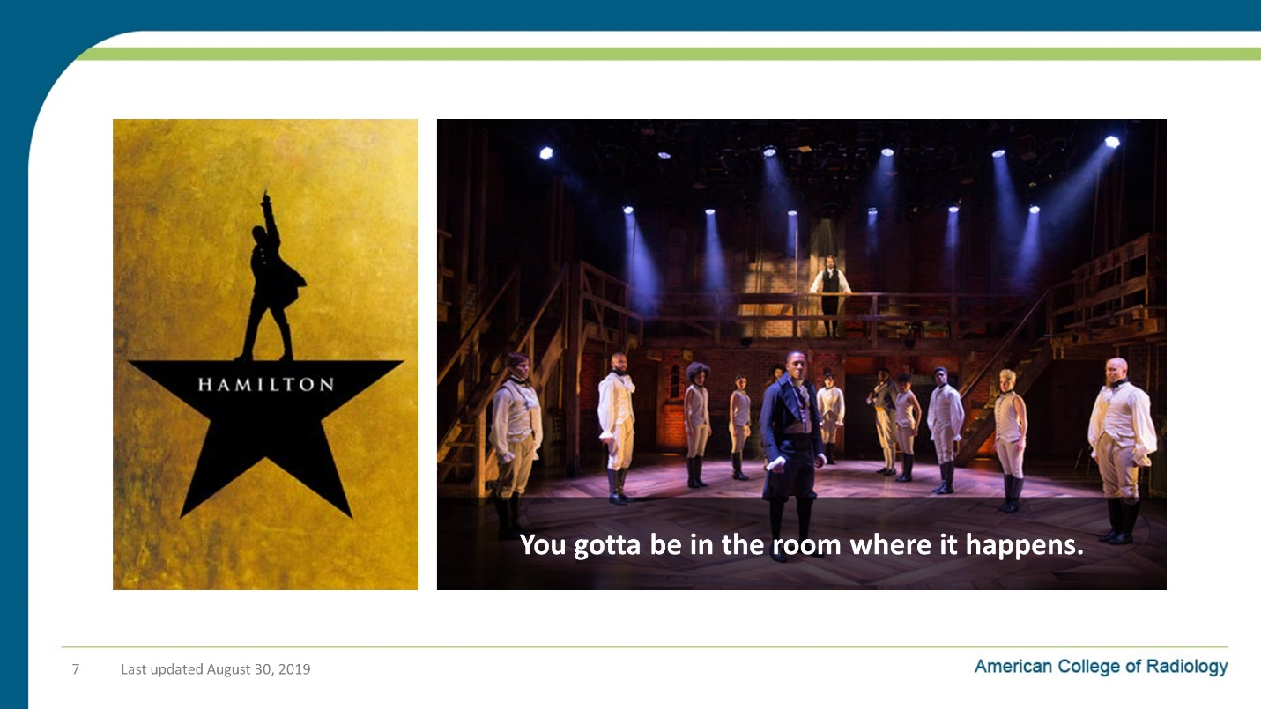

Notes on Slide 7:
- For a long time, we (radiologists) had been too much of the outskirts of the work that was happening in Washington and in our communities to reshape the US healthcare system.
- Which is too bad, because we bring a ton of insight and value to the table.
- But we hadn’t consistently communicated that value to all of the stakeholders in the US healthcare system.
- PAMA was a huge milestone in radiologists getting a much bigger seat at the table.
- For fans of the musical show Hamilton, PAMA helped us get in The Room Where It Happens.

Slide 8: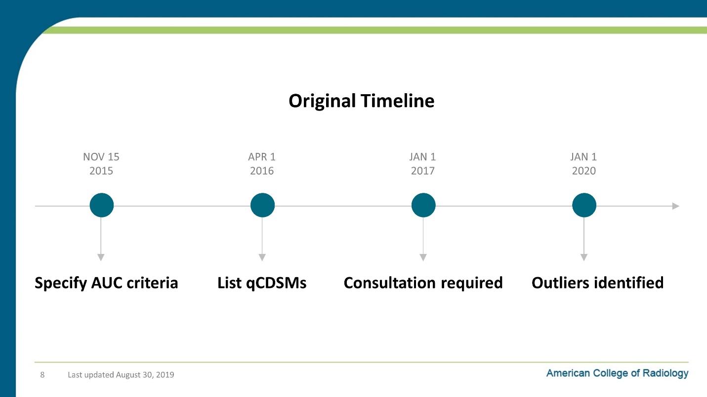

Notes on Slide 8:
The original deadline for implementation of CDS was January first of 2017.

Slide 9: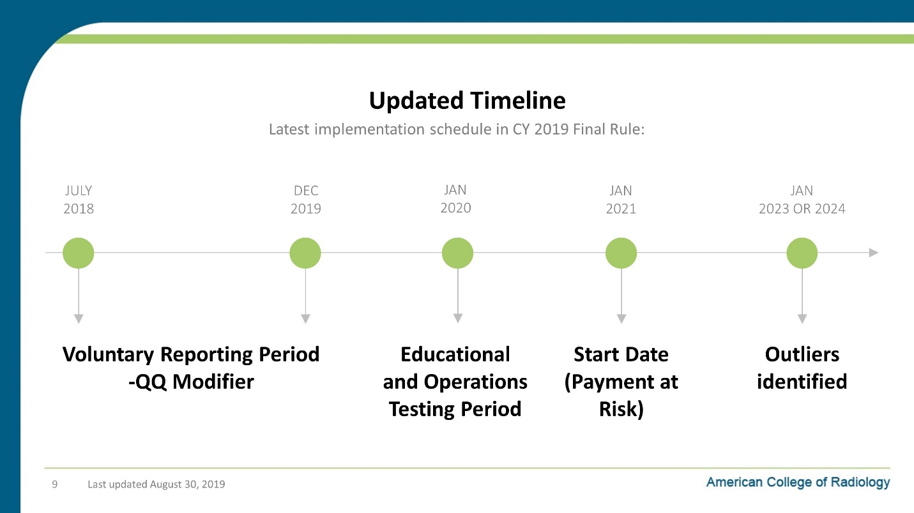

Notes on Slide 9:
This deadline has been moved back a few times and is going now January 1st of 2020.

Slide 10: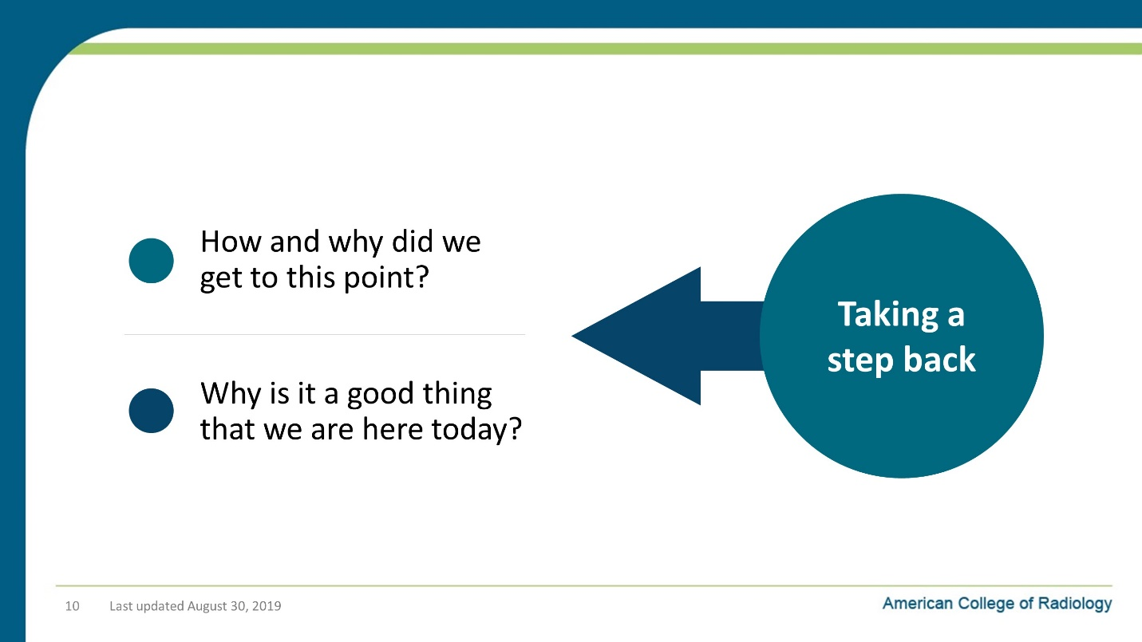

Notes on Slide 10:
So let’s take a step back and answer a couple of key questions:
- Why is it a good thing that we are here today?
- How and why did we get to this point?

Slide 11: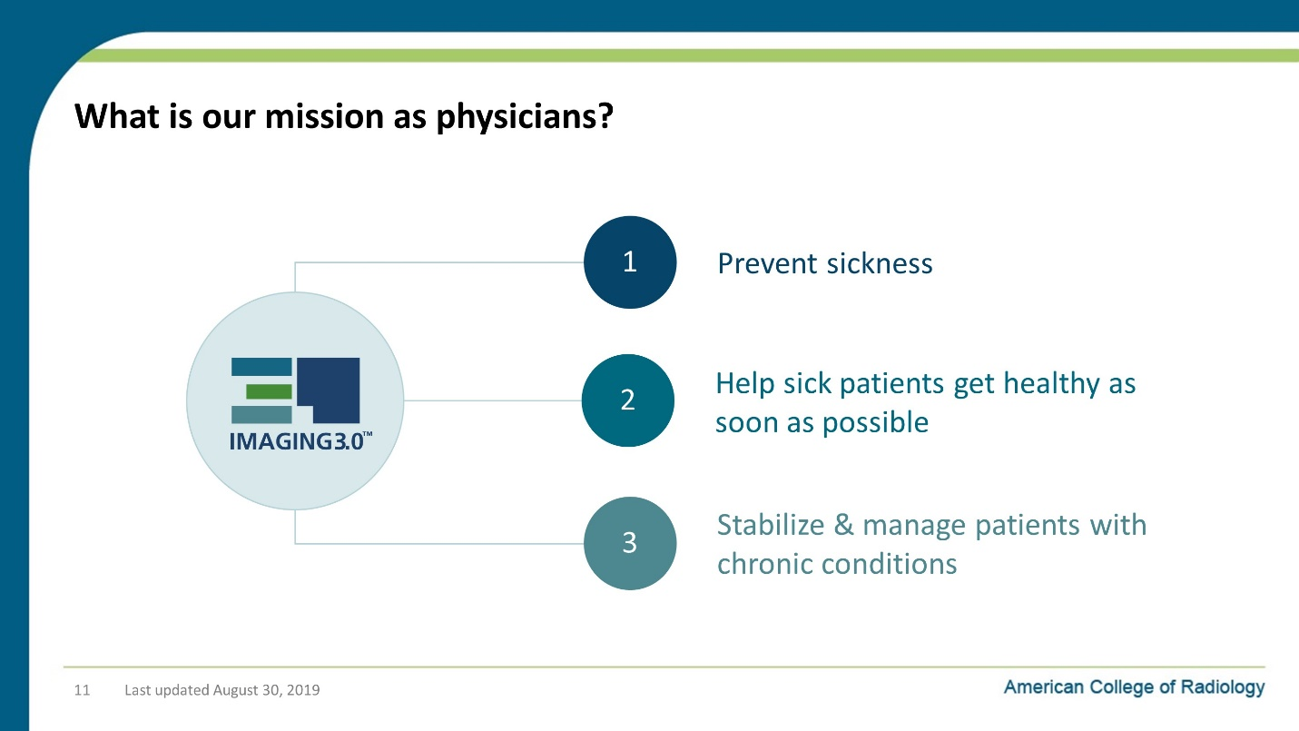

Notes on Slide 11:
You all are incredibly busy people. You work hard every day to:
- Deliver great care to your patients and
- Run a successful practice.
There are a number of different types of activities that compete for your time.
You don’t have time to work on them all, so you have to decide which ones are the most important, knowing that none of them are unimportant!
So why should you care about CDS? What’s in it for you? Why does it deserve your attention?
Here’s the bottom line:
- We do 3 basic things in medicine: :
  - First - Keep people from getting sick,
  - Second – When they are sick, get them healthy as soon as possible
  - Third - When they have a chronic condition, keep their condition well managed and their quality of life high.
- But the world is a complicated place and, unfortunately, we can’t just come into work every morning and just practice medicine 100% focused on our patients and getting them well.

Slide 12: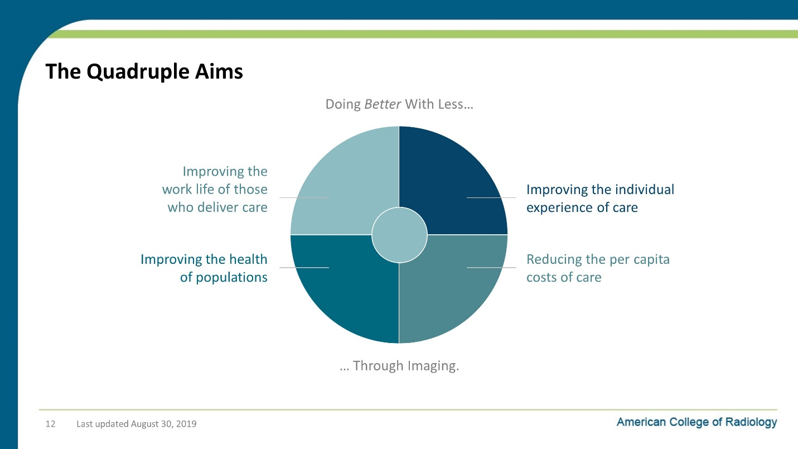

Notes on Slide 12:
Instead we come to work every day and have to fight for our patients against larger forces that are driven by economics and the bureaucracies that grow out of those economic conditions.
But there is good news:
First, there is a lot of alignment in the US healthcare system about what changes we want to see in our healthcare systems, even if there is an absence of agreement in how we get there.
The Quadruple Aims outlined here are our guideposts. What we need is:
- To improve the health of populations,
- To improve our patient’s individual care experiences,
- To reduce the cost per capita that we spend on care, and
- To improve the work life of those who deliver care.
The second piece of good news is that:
- With accountable care, we’re now being financially incented to do the right things for our patients and those paying for their care
The third piece of good news for radiologists is that:
- For the entire system to succeed at accountable care and the Quadruple Aims, our healthcare system needs to use imaging as efficiently and effectively as possible. Which means we have a LOT of value to add.
- And we can finally get out of this zero-sum-game thinking about carving up the limited dollars the healthcare pie.
- Instead we can create a situation where we all win: Patients and their families. Healthcare systems. Referring physicians. Radiologists. Employers. And payers.

Slide 13: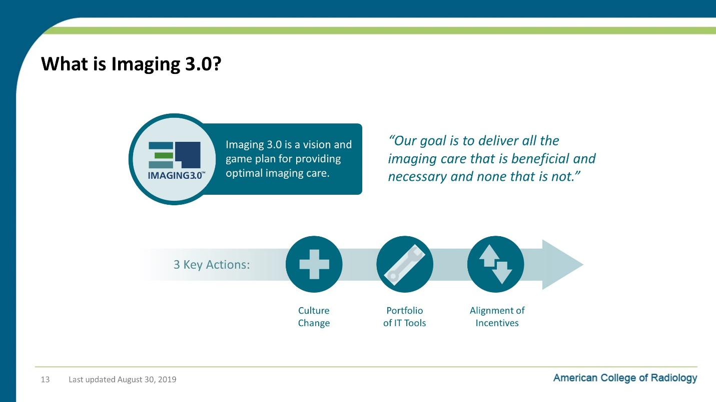

Notes on Slide 13:
So as many of you may already know, radiology as a specialty has developed our own point-of-view on how to get to the other side of healthcare transformation, and we are acting on it every day.
It’s called Imaging 3.0.
Imaging 3.0 is both the vision and game plan to achieve our goal. And our goal as radiologists, to put it succinctly, is:
- To provide optimal imaging care from the moment a clinician considers ordering an imaging study or treatment
- until that referring physician receives and
- understands an actionable report with evidence-based recommendations.
Imaging 3.0 is about “delivering all the imaging care that is beneficial and necessary and none that is not.”
It’s the way that radiologists have been rapidly moving from volume to value.
And we’re getting there by doing three key things:
- First, we’re changing the culture in radiology and the entire healthcare system.
  - Specifically, we’re more tightly integrating radiologists and their knowledge into healthcare delivery.
- Second, we’re rolling out informatics tools like clinical decision support for the ordering of images, clinical decision support for the interpretation of images and patient data registries.
- And third, as you already saw in the opening slides, we’re changing the policy conversation in Washington about how imaging is paid for.

Slide 14: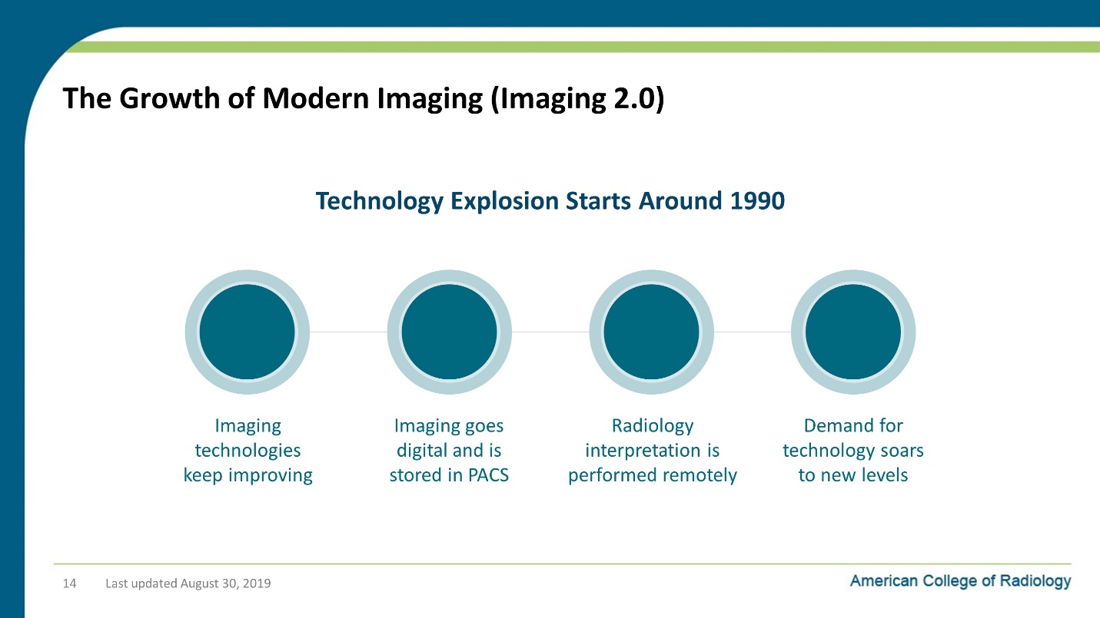

Notes on Slide 14:
Continuing our step back to look at how we got here, the modern period of imaging (which we often call Imaging 2.0) starts around 1990.
This is when we see
- CT, MRI and PET go mainstream.
- Imaging goes digital and we start storing images in PACS databases.
- And because of PACS, radiology interpretation starts being performed remotely.
- When we put it all together, demand for imaging and radiologists to interpret those images goes way up.

Slide 15: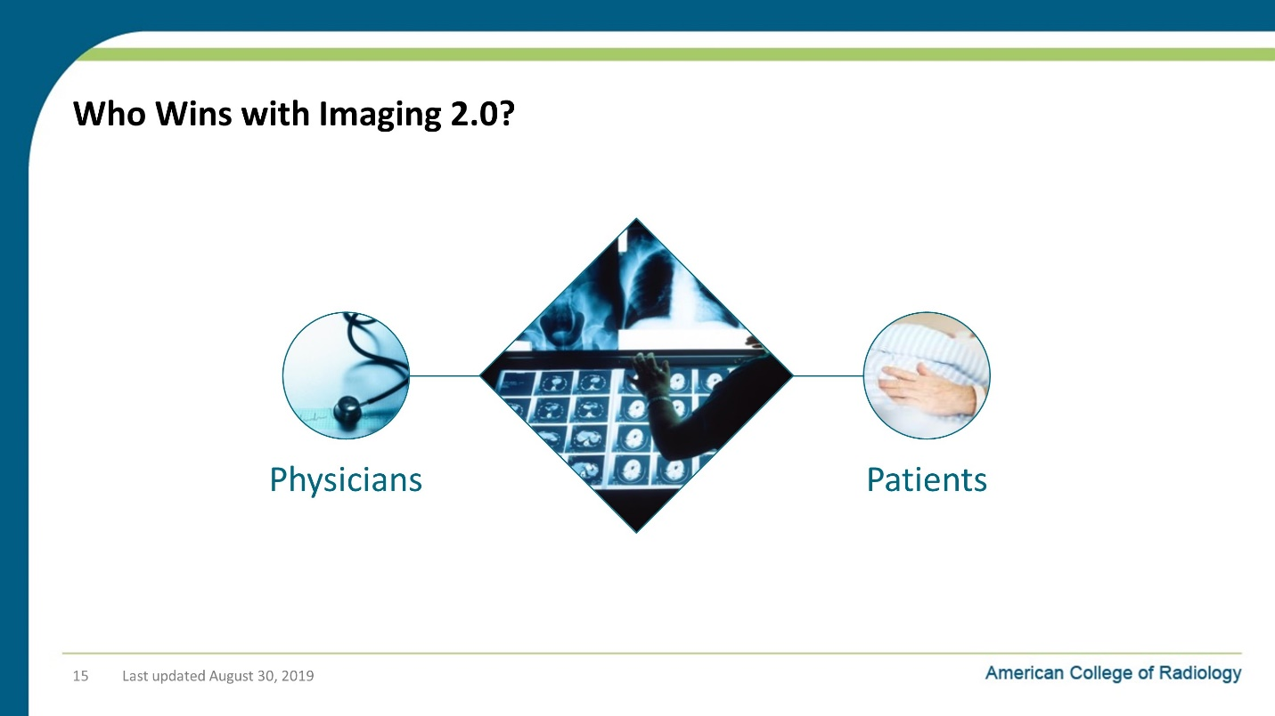

Notes on Slide 15:
So there are some winners in the Imaging 2.0 era.
The biggest winners are patients and their providers who get better diagnostic tools.

Slide 16: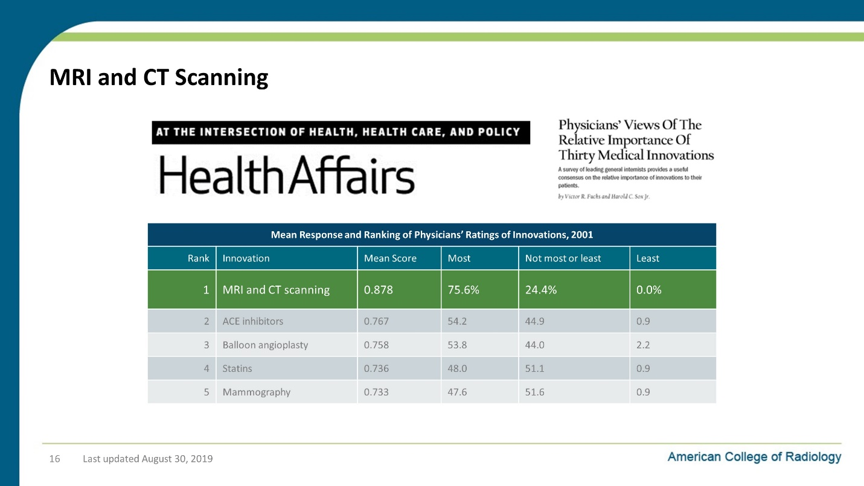

Notes on Slide 16:
Just talk to doctors who practiced medicine before CT and MRI. They’ll tell you how invaluable it is.
This is a study where internists were asked to name the most important innovations in medicine.
- What you’ll see is that MRI and CT came in first place by a pretty wide margin.
- Just try fighting cancer without imaging
- Or when was the last time you heard someone say, “I’m having exploratory surgery because my doctor can’t figure out what’s wrong with me and has to open me up to see what’s what?”

Slide 17: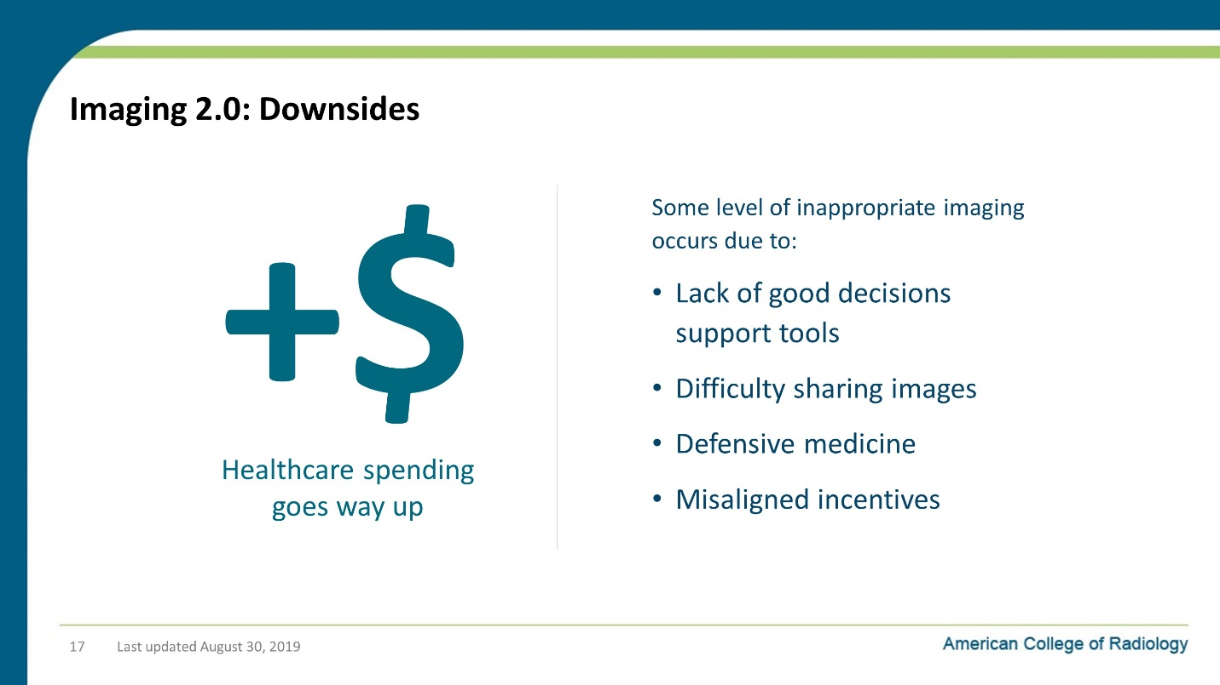

Notes on Slide 17:
But there are also some downsides to the Imaging 2.0 era
- Some level of inappropriate imaging occurs due to a number of factors:
  - Lack of good decisions support tools,
  - difficulty sharing images,
  - defensive medicine and
  - Misaligned financial incentives.
- And this is the same period where healthcare spending goes way up.
  - And imaging definitely plays a role in this until about 2006 when the growth rate for spending on imaging really starts to level off compared to other categories of healthcare spending.
Citations:
- Kaiser Fact Sheet Publication (#7692-02). Trends in Health Care Costs and Spending, March 2009, http://kaiserfamilyfoundation.files.wordpress.com/2013/01/7692_02.pdf.
- AJR Am J Roentgenol. 2013 Dec;201(6):1277-82. doi: 10.2214/AJR.13.10999. Comparative analysis of Medicare spending for medical imaging: sustained dramatic slowdown compared with other services. Lee DW, Duszak R Jr, Hughes DR.

Slide 18: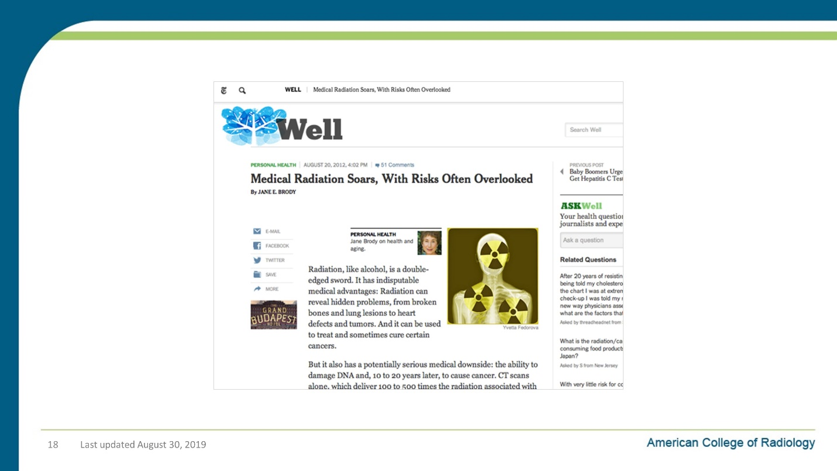

Notes on Slide 18:
In this period, we also start paying more attention to risks of excessive and unnecessary radiation exposure.

Slide 19: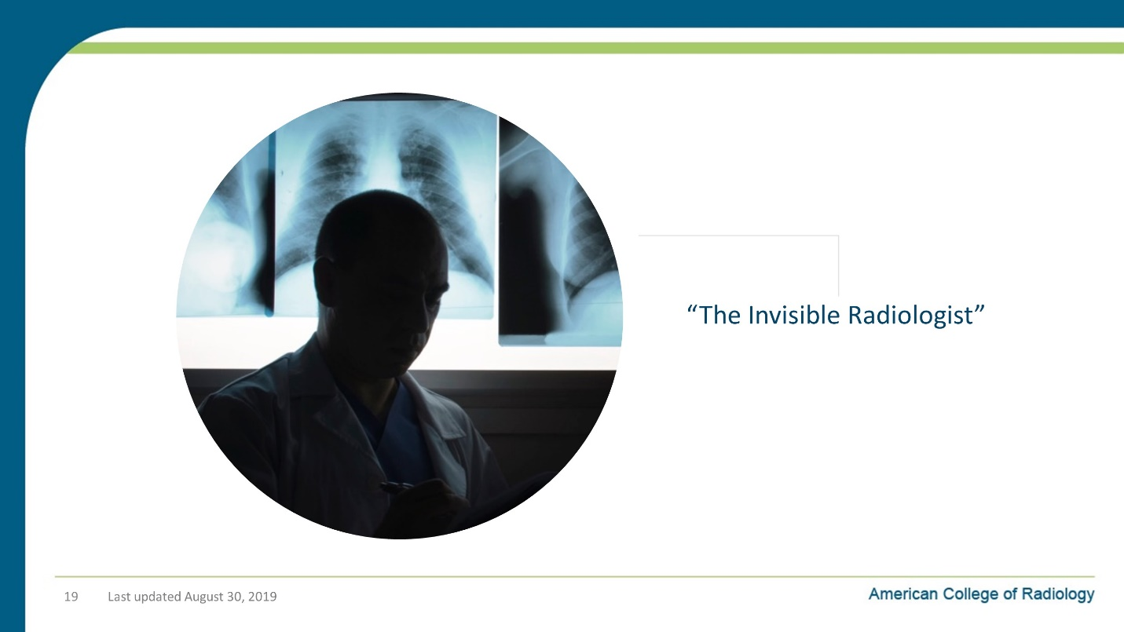

Notes on Slide 19:
There’s one other important loss in this period that’s often overlooked:
- When the images go digital, the radiologist’s work lists in their PACS becomes their main interface.
- It’s a powerful interface, but it’s not a particularly collaborative or patient-centric.
- And that face-to-face collaboration with the ordering physician in the reading room largely goes away.
- Some of us become what’s known as “The Invisible Radiologist” in a basement reading room that no other doctors ever visit.

Slide 20: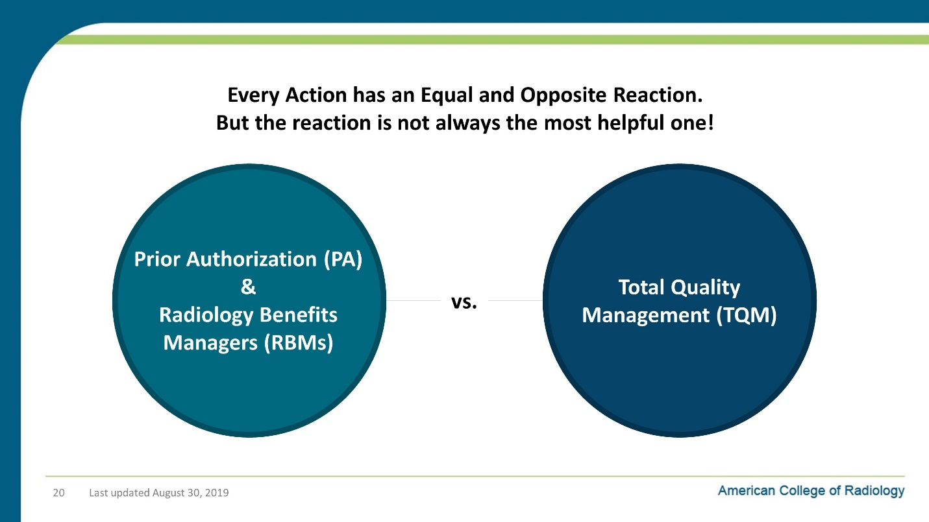

Notes on Slide 20:
So what happens in response to the growth in imaging utilization?
We see an equal and opposite reaction: Payors implement a roadblock that’s intended to stop “runaway” imaging orders.
The fundamental issue is that while inappropriate imaging is a problem of healthcare quality and cost control is an issue as well, prior authorization is a terrible solution.
If you look at the ideas of Total Quality Management (TQM) which revolutionized business and organizations, what is says that, “When the process is broken, you don’t patch up the low-quality outputs after they roll off the factory line. You find the source of the quality problem and fix it!”
If too many inappropriate images are being ordered, then fix the way that we order the images so that doctor orders the right imaging study the first time.
Don’t spend your best energy trying to correct the order after it has been created!

Slide 21: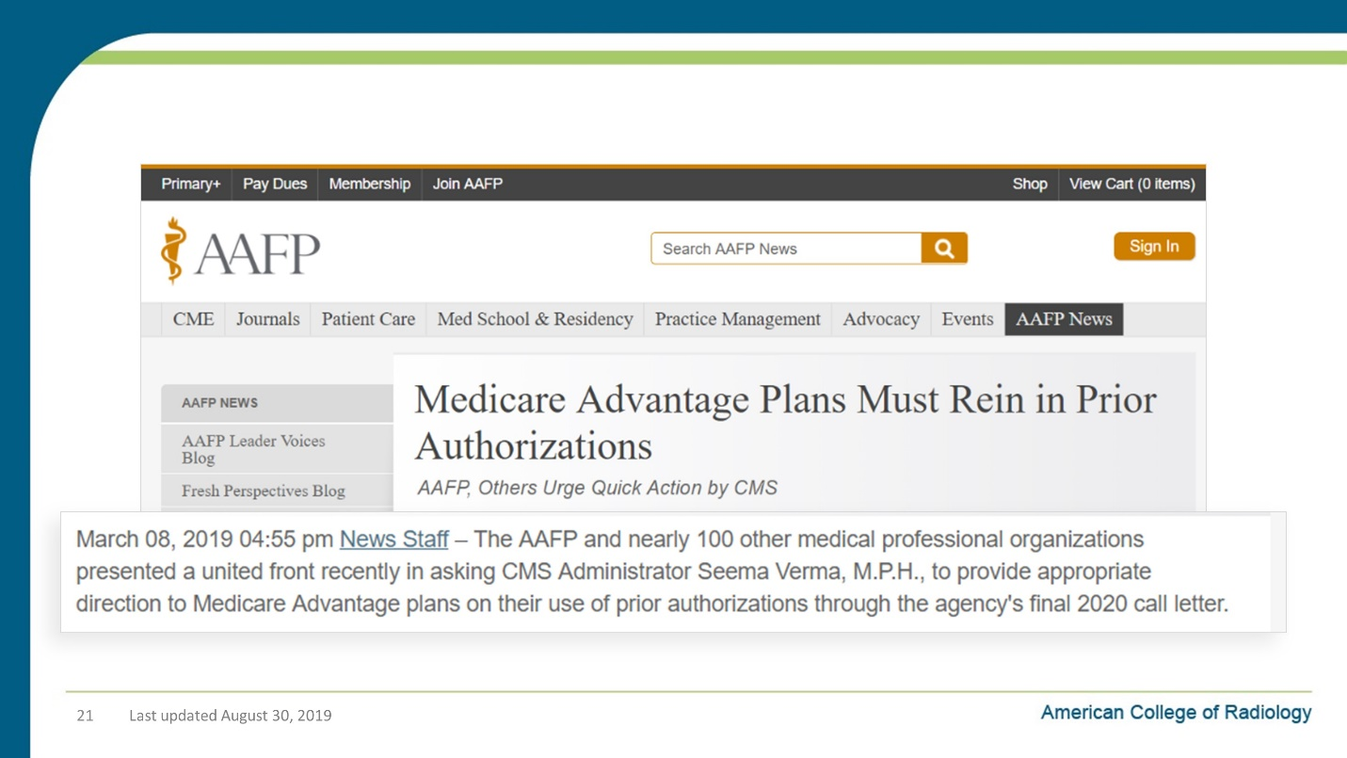

Notes on Slide 21:
I don’t have to show you evidence about how much everyone in the provider world (and patient world) truly hates prior authorization.

Slide 22: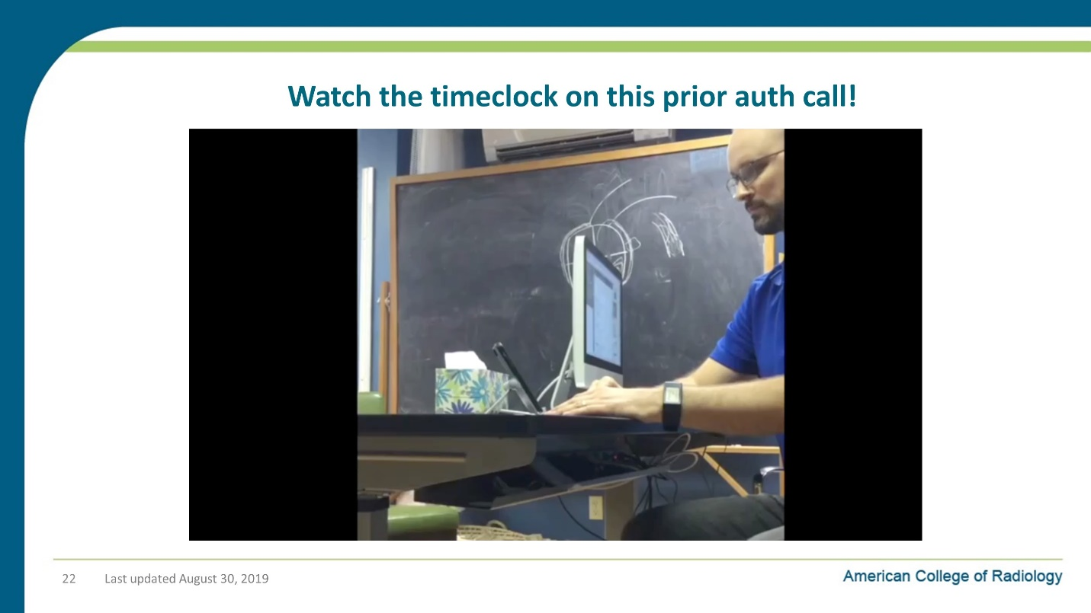

Notes on Slide 22:
I know I don’t need to belabor the point of how much clinicians and patients hate prior authorization.
And there has been a lot of research done on in inordinate burden of time that this puts on the system, not to mention huge frustration for everyone involved.
But the best way to sum it up might be to show you some clips from a YouTube video posted by Dr. Ryan Neuhofel, a Family Medicine physician in Kansas.
In this video, he spends 20 minutes trying to obtain prior authorization for a CT scan for a patient who clearly needs one. Why?
Because the patient has a gross physical abnormality on his skull.
And the end result of his 20 minute call to the insurer’s RBM, which by the way contained maybe 30 seconds of clinical content, the doctor is told that they will fax him paperwork which he should fill out and send back!

Slide 23: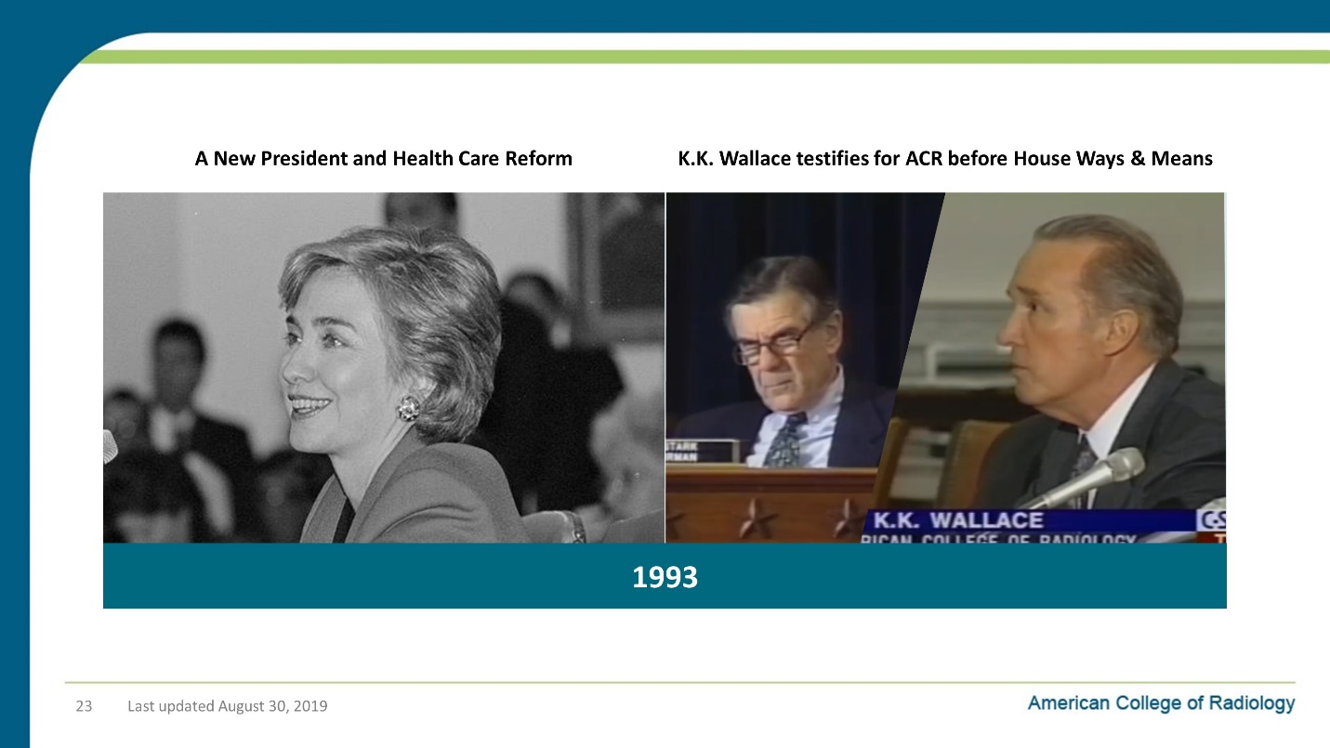

Notes on Slide 23:
Radiology’s response to this challenge dates back to the Clinton Administration’s attempt at healthcare reform.
In response to this, the ACR tells Congress that we’re going to do our part to find a responsible solution that helps both patients and taxpayers.
We pledge that the ACR will:
- Take a leadership role in defining the most cost-effective and beneficial ways of utilizing radiologic services
- Design a system of patient care guidelines to eliminate inappropriate utilization of imaging services
And we follow through…. in a big way.

Slide 24: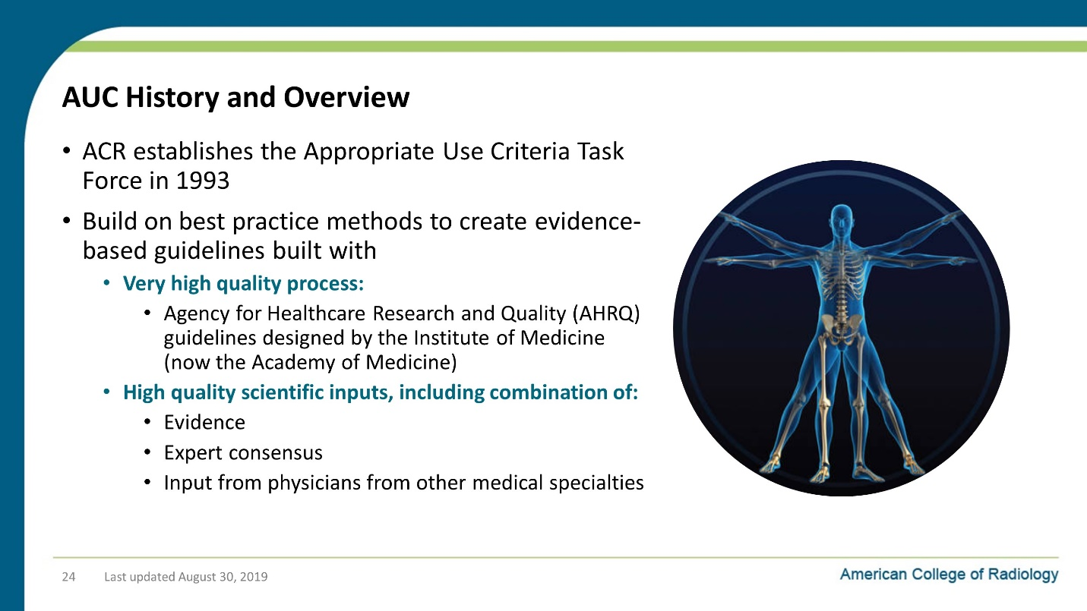

Notes on Slide 24:
The ACR establishes the Appropriate Use Criteria Task Force in 1993
It Build on best practice methods to create evidence-based guidelines built with:
A very high-quality process:
Agency for Healthcare Research and Quality (AHRQ) guidelines designed by the Institute of Medicine (now the Academy of Medicine)
High quality scientific inputs, including combination of:
Evidence
Expert consensus
Input from physicians from other medical specialties

Slide 25: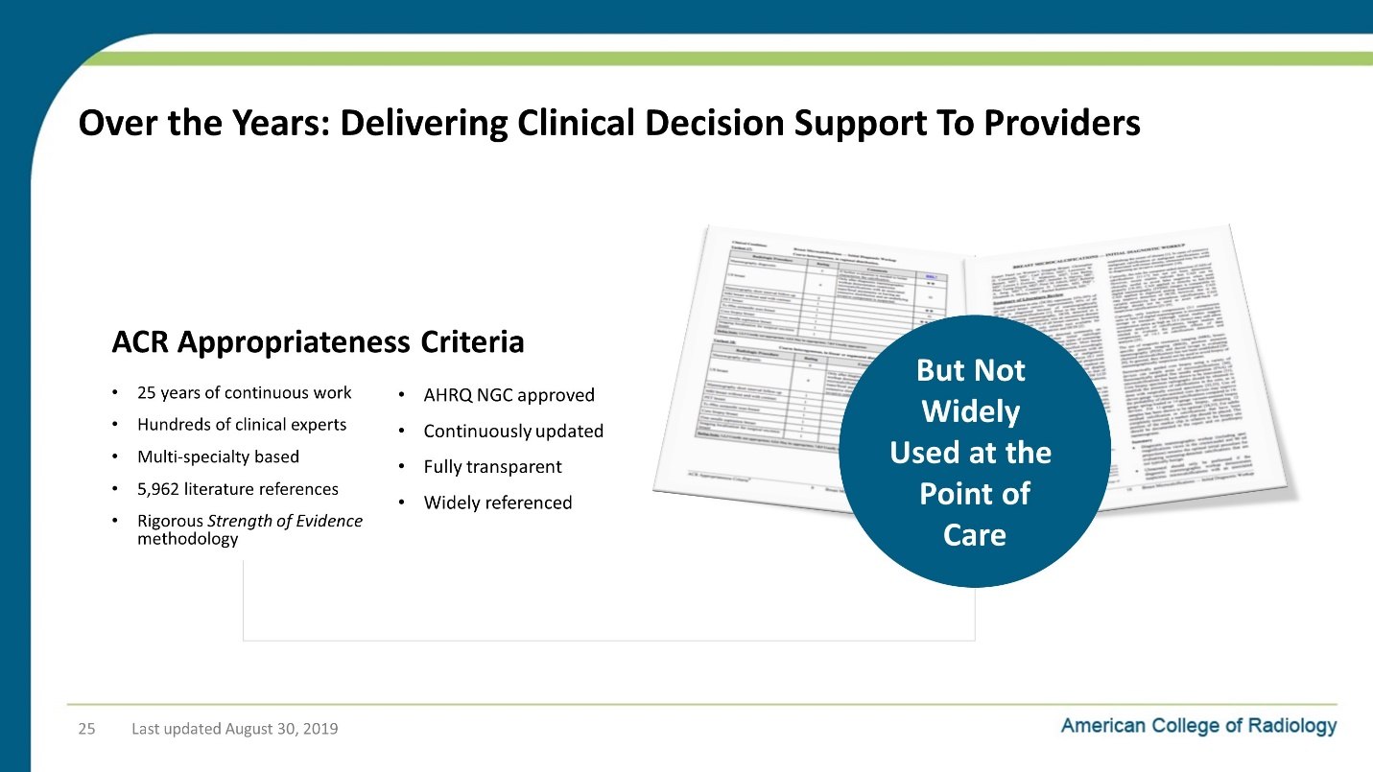

Notes on Slide 25:
And they get to work creating the ACR Appropriateness Criteria
- 25 years of continuous work
- Hundreds of clinical experts
- Multi-specialty based
- 5,962 literature references
- Rigorous SOE methodology
- AHRQ NGC approved
- Continuously updated
- Fully transparent
- Widely referenced
The problem was that these tools were not widely consulted by physicians when they actually wanted to write an order for an imaging study for the patient they were sitting with.
There were attempts to create interfaces that made it easier to consume this data at the point of care, like a little book that was a Pocket Guide for the ACR Appropriateness Criteria.
But none of these types of tools were ideal since the doctor has to stop and take the time out of their workflow to find the guide, look up the appropriate guideline, read the guideline and then figure out how it fits the presenting patient.

Slide 26: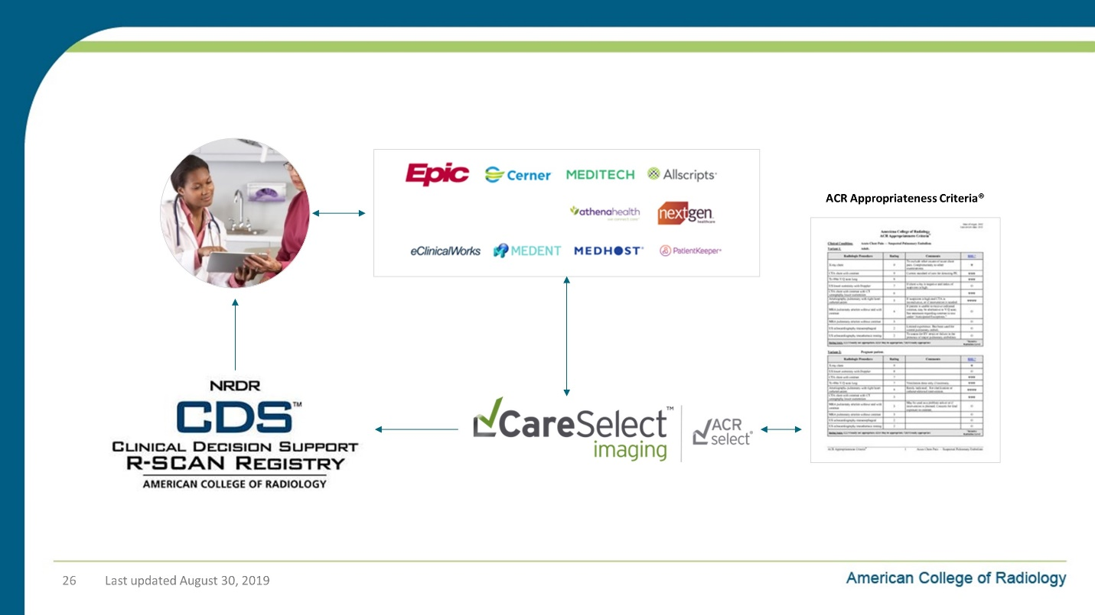

Notes on Slide 26:
That all changed as EHR systems began to be broadly adopted.
Suddenly we could embed our clinical content directly into the EHR systems so that it could become a part of the workflow of ordering an image
Early in this decade, we started a process of converting this content from the PDF style documents you see on the right into a database of clinical content that can be integrated directly into an Electronic Health Record Ordering System.
And we also set up a national registry on the back end so that all orders are captured for reimbursement reporting to CMS, for your quality improvement work and for research at a local and national level.

Slide 27: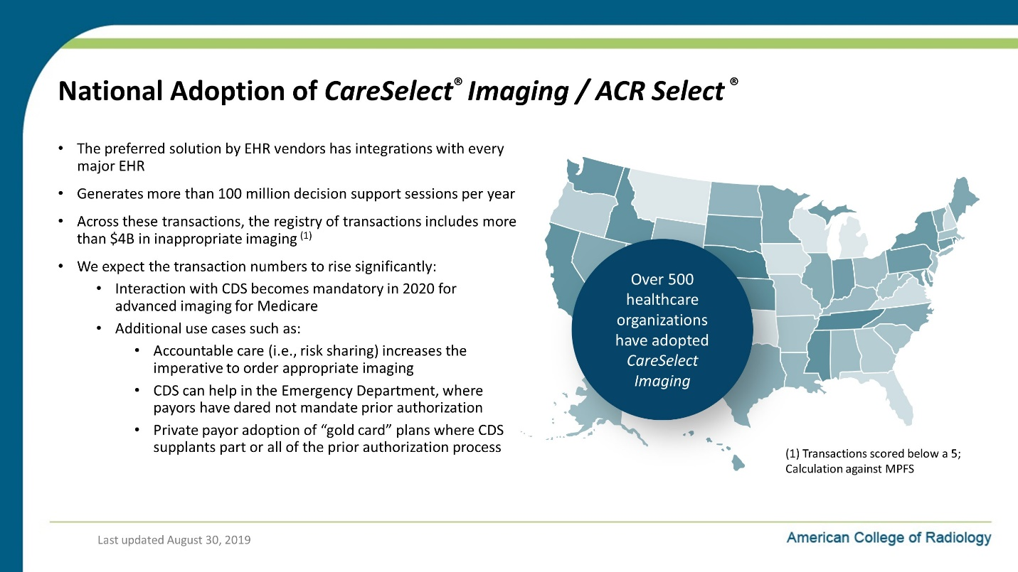

Notes on Slide 27:
CDS for appropriate imaging orders has seen strong growth in the time since PAMA was passed.
CareSelect® Imaging / ACR Select ® is the preferred solution by EHR vendors and has integrations with every major EHR
It generates more than 100 million decision support sessions per year
Across these transactions, the registry of transactions includes more than $4B in inappropriate imaging ⁽¹⁾
We expect these numbers to rise significantly for a few reasons:
- Interaction with CDS becomes mandatory in 2020 for advanced imaging for Medicare
- Additional use cases such as
  - Accountable care (i.e., risk sharing) increases the imperative to order appropriate imaging
  - CDS can help in the Emergency Department, where payors have dared not mandate prior authorization
  - Private payor adoption of “gold card”-type plans where CDS replaces part or all of a prior authorization process

Slide 28: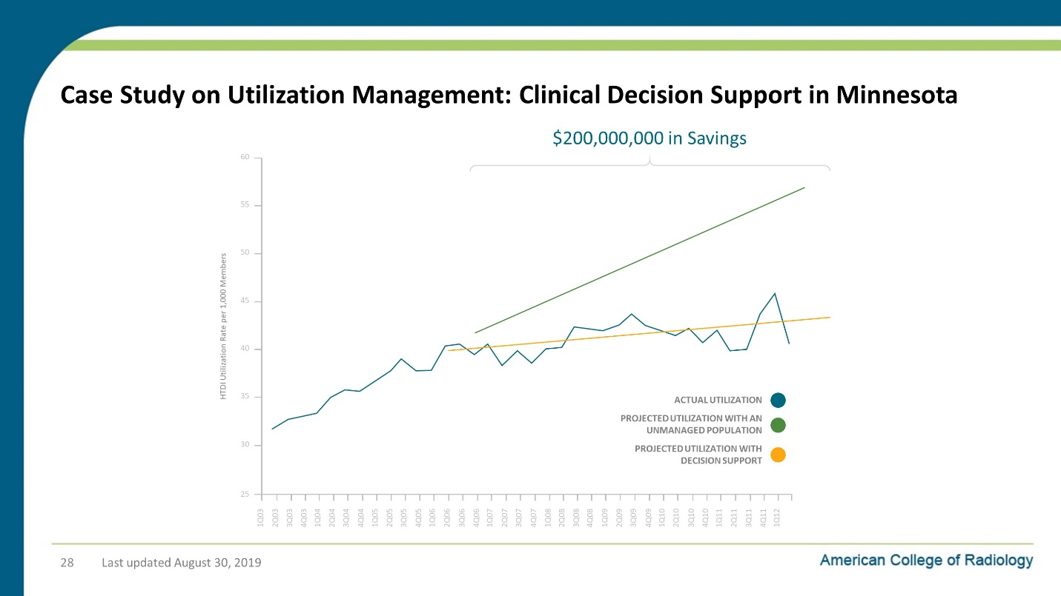

Notes on Slide 28:
One great case study about the use of decision support for ordering diagnostic images is from Minnesota.
This study was one of the key pieces of evidence that helped sway Congress and the President enact PAMA in 2014.
Back in 2006 they were projecting that by 2012 the MN imaging utilization rate was going to rise from just over 40 studies per 1000 members to almost 56 studies per 1000. (That’s the green line in this graph.)
But with clinical decision support, this growth was largely halted.
The yellow line in this graph is the revised projected growth with CDS.
And the yearly actuals are the blue line.
This has translated into a savings of over $200 million to payers and patients over a six year period, which doesn’t even reflect the improvements in patient care that come from skipping unnecessary imaging.

Slide 29: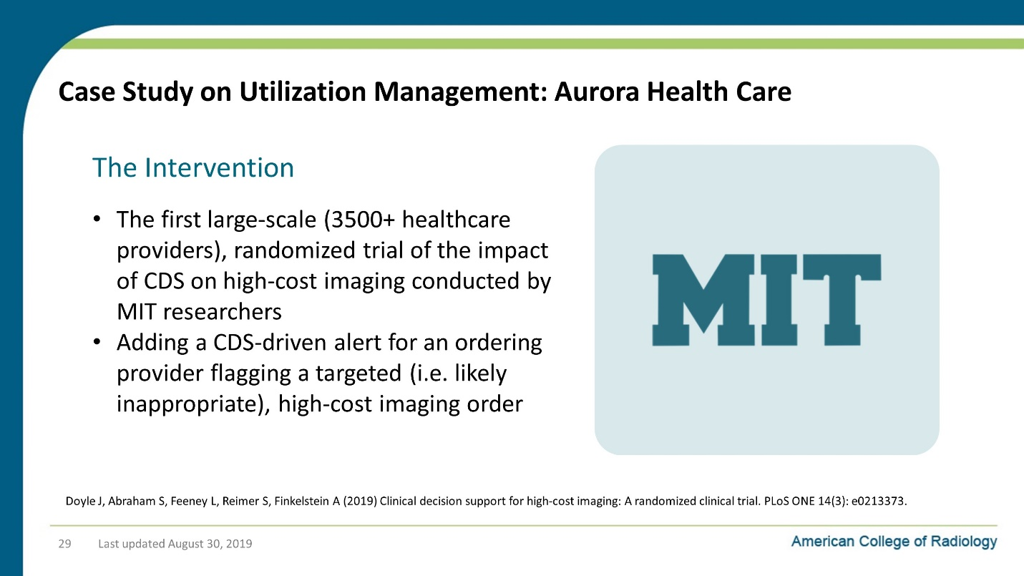

Notes on Slide 29:
Aurora Health Care in Wisconsin teamed up with a healthcare economics at MIT (who happens to be a McArthur genius fellow) to do the first large-scale (3500+ healthcare providers), randomized trial of the impact of CDS on high-cost imaging conducted.
This was an important step forward in evidence-based effectiveness research for CDS

Slide 30: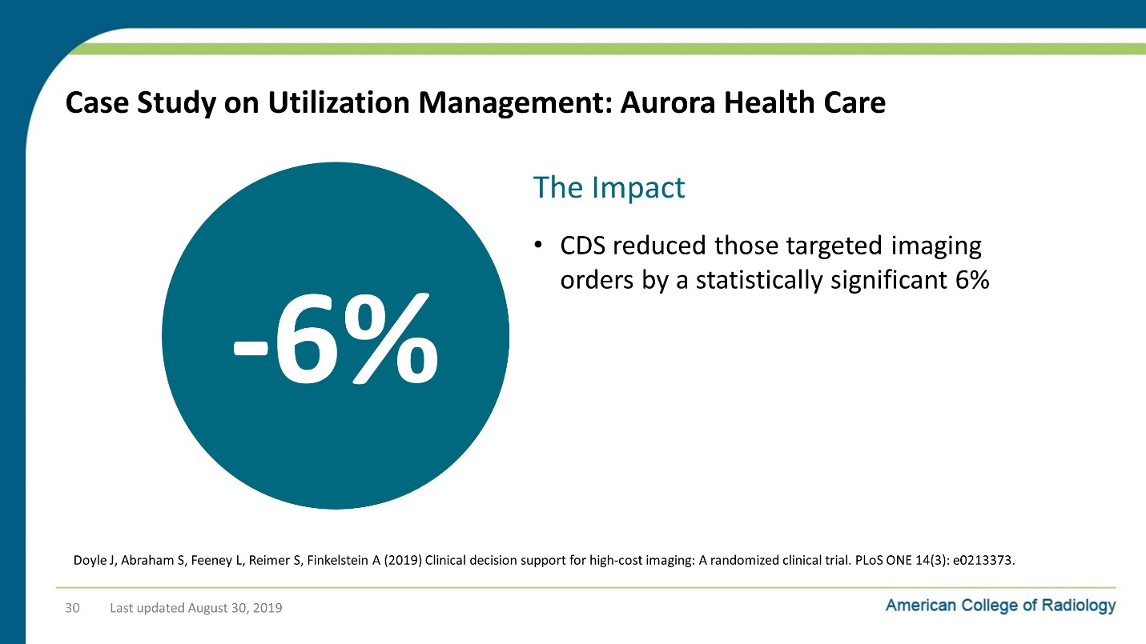

Notes on Slide 30:
What they found was that for the high-cost orders they targeted that were known to have high levels of inappropriate ordering, by using CDS to call that out to the ordering clinician in real time, they were able to reduce the inappropriate orders by 6%!

Slide 31: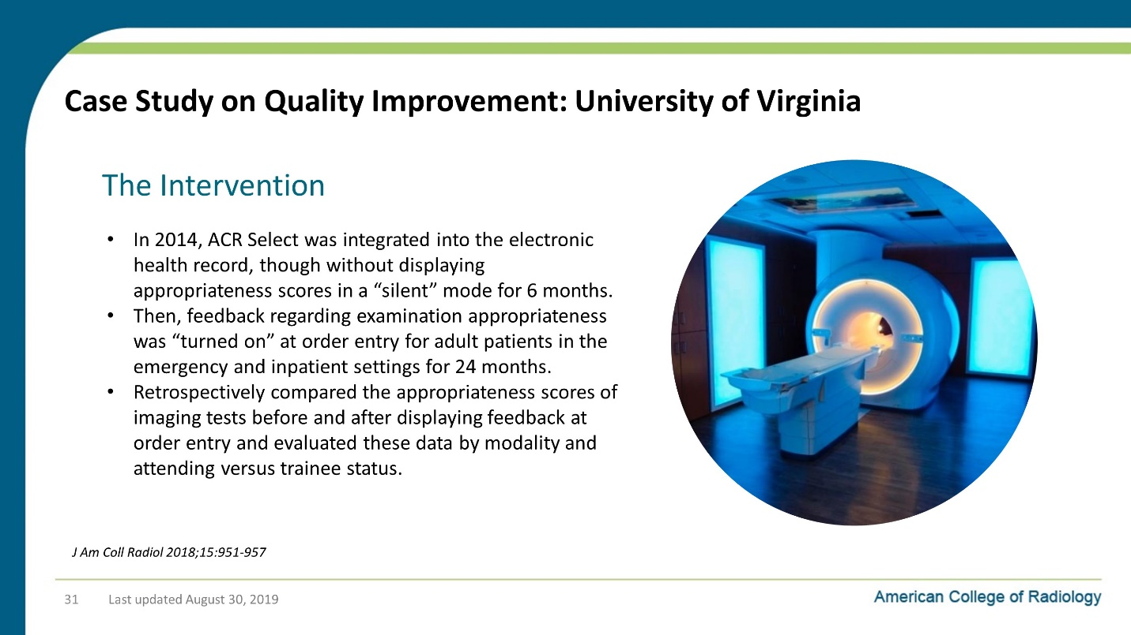

Notes on Slide 31:
Slide 32: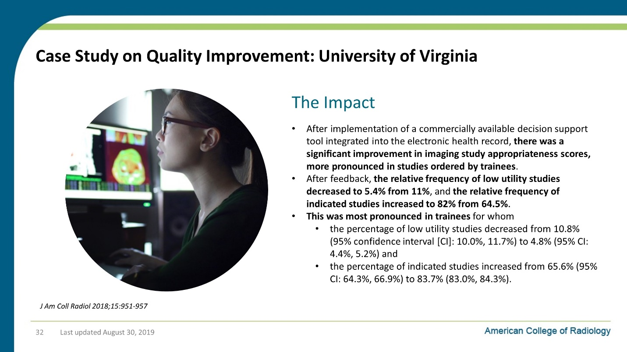

Notes on Slide 32:
Slide 33: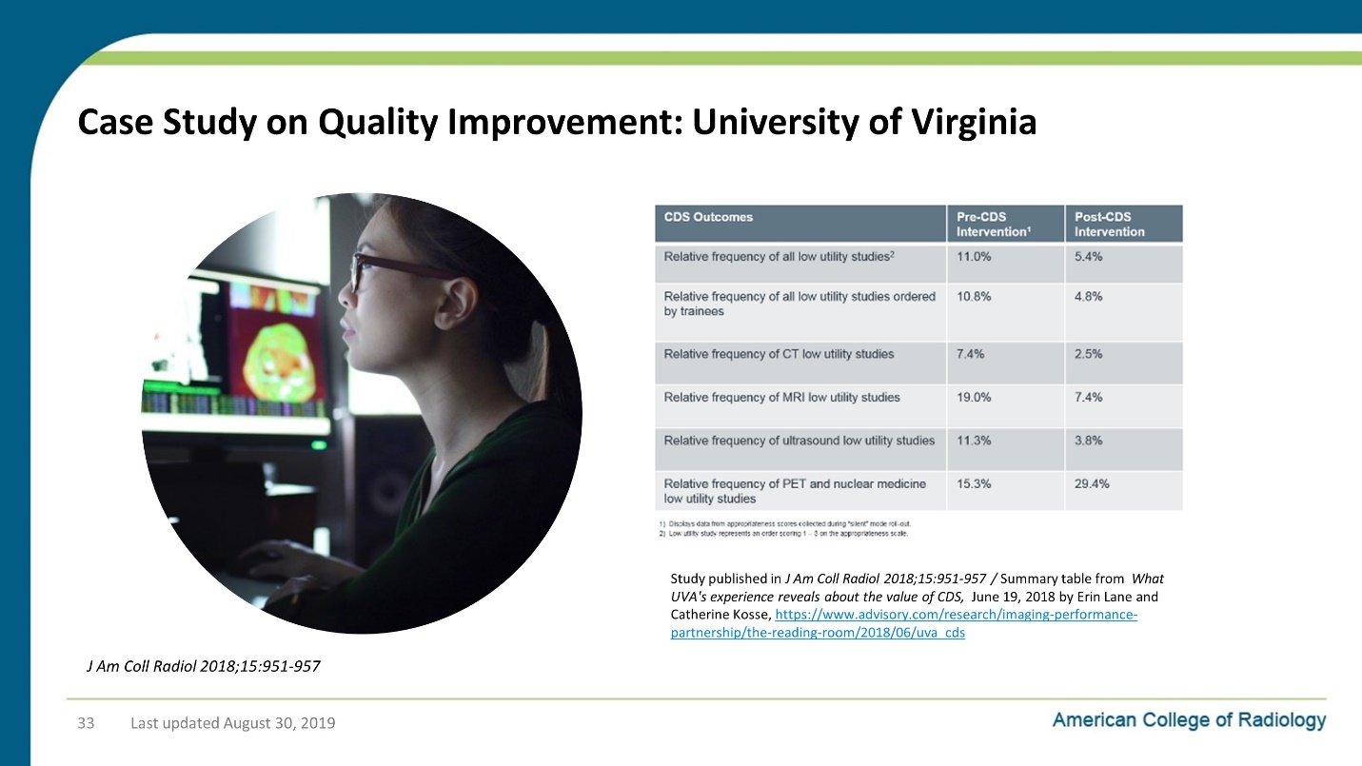

Notes on Slide 33:
Slide 34: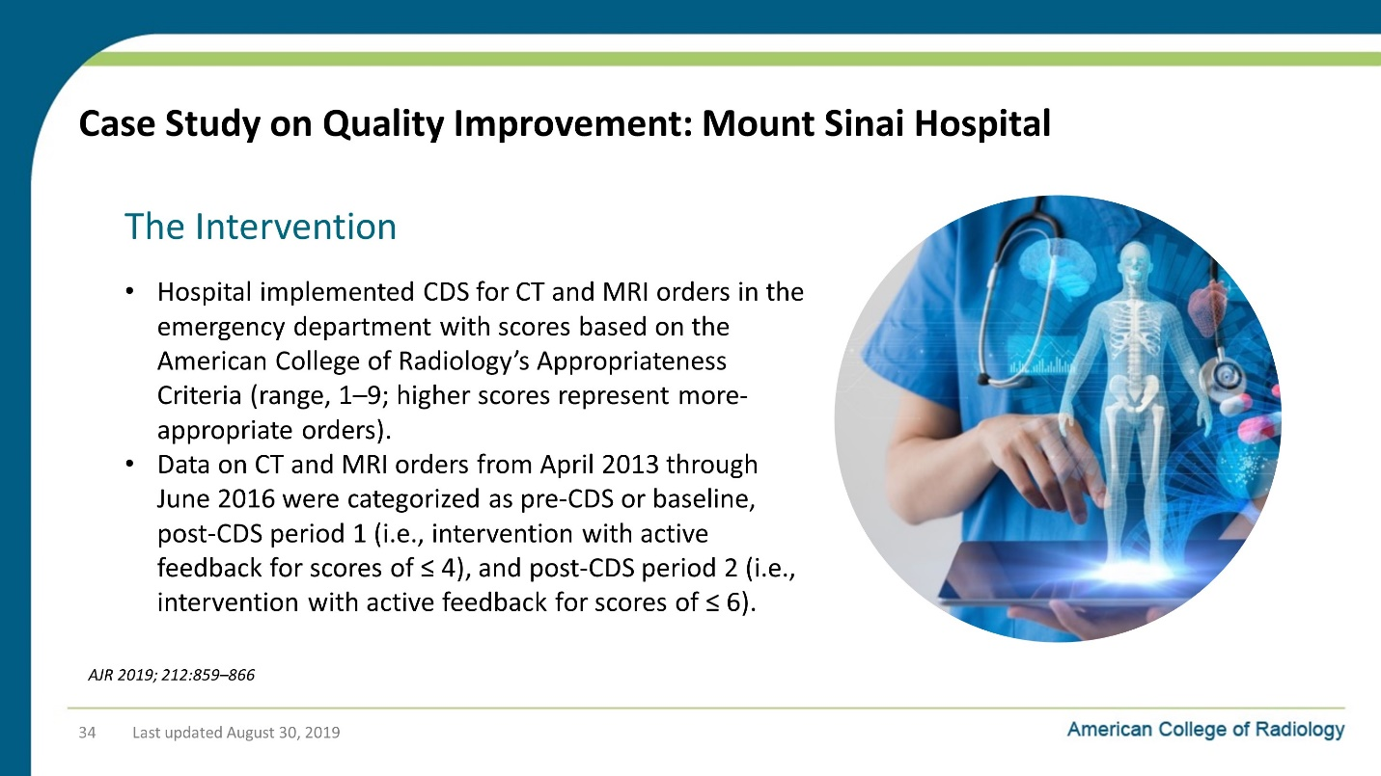

Notes on Slide 34:
Slide 35: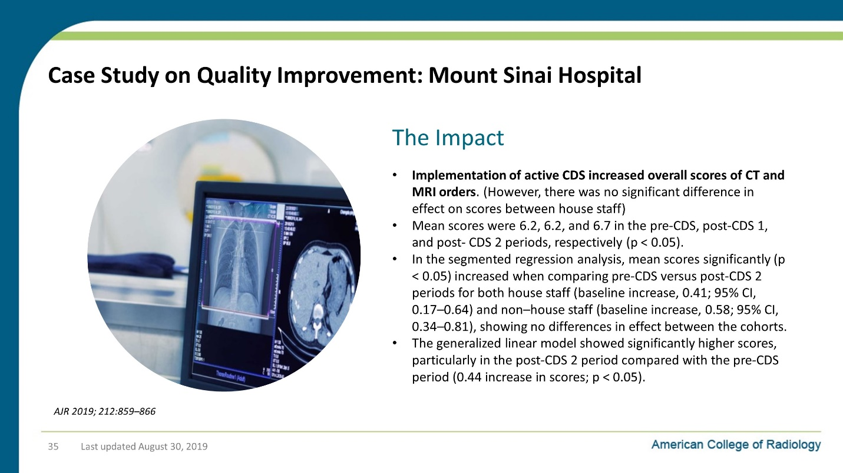

Notes on Slide 35:
Slide 36: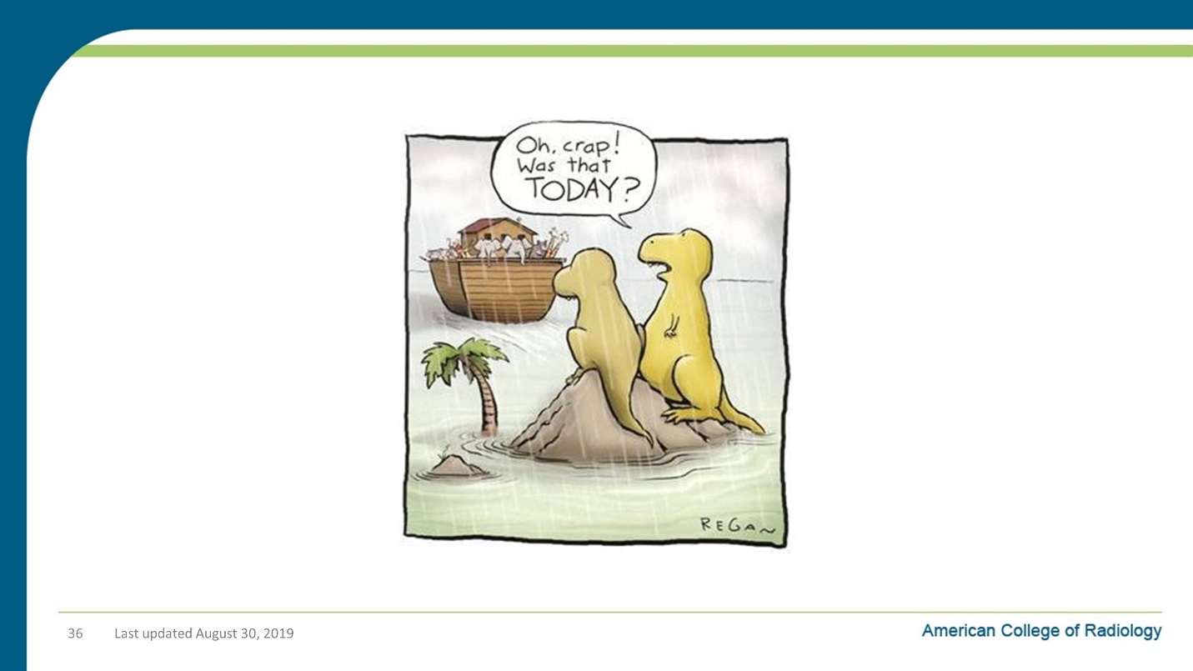

Notes on Slide 36:
So this is really your last chance to get on the CDS boat if you want to help drive the boat instead of just being a passenger.
CDS will go much, much better in your healthcare system if you get involved.
Frankly, you might get blamed if your referring providers don’t like it.
We want this tool to be helpful to physicians and seen as a welcome replacement to prior authorization.
And we certainly don’t want it to be seen as a new roadblock to the ordering of necessary imaging.

Slide 37: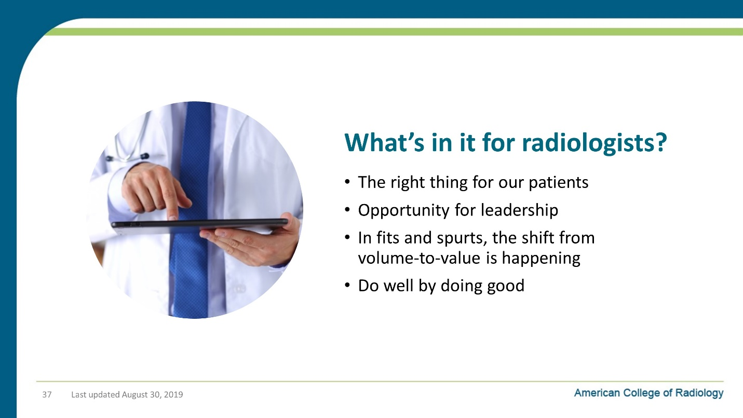

Notes on Slide 37:
So what’s in this for we radiologists?
Right for the patient/care
- Are you sick of reading studies that never should have been ordered or could have been so much more useful if they had been ordered differently?
Opportunity for leadership
- We know so much about patient care and how the healthcare system works
- Our broad view across all specialties, everyone needs diagnosis and tracking
In fits and spurts, the shift from volume-to-value is happening
- Be in the room where it happens
- Based on the value we bring from stepping up, be compensated for this value
“Do Well By Doing Good”
- We will see the impact of that both Nationally and Locally

Slide 38: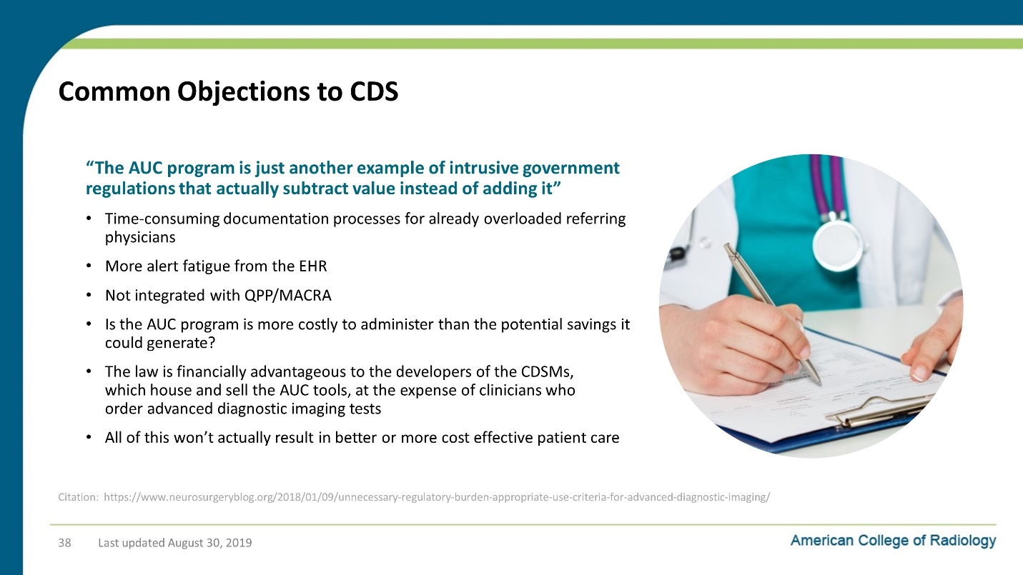

Notes on Slide 38:
It’s very likely that you will hear objections to CDS from referring physicians.
And I want to be clear, there is merit to some of the points that they raise. CDS is not a silver bullet or a panacea.
Here are some of the commonly heard points:
- Time-consuming documentation processes for already overloaded referring physicians
- Not integrated with QPP/MACRA
- Is the AUC program is more costly to administer than the potential savings it could generate?
- The law is financially advantageous to the developers of the CDSMs, which house and sell the AUC tools, at the expense of clinicians who order advanced diagnostic imaging tests
- All of this won’t actually result in better or more cost effective patient care
In short, critics say that the AUC program is just another example of intrusive government regulations that actually subtract value instead of adding it

Slide 39: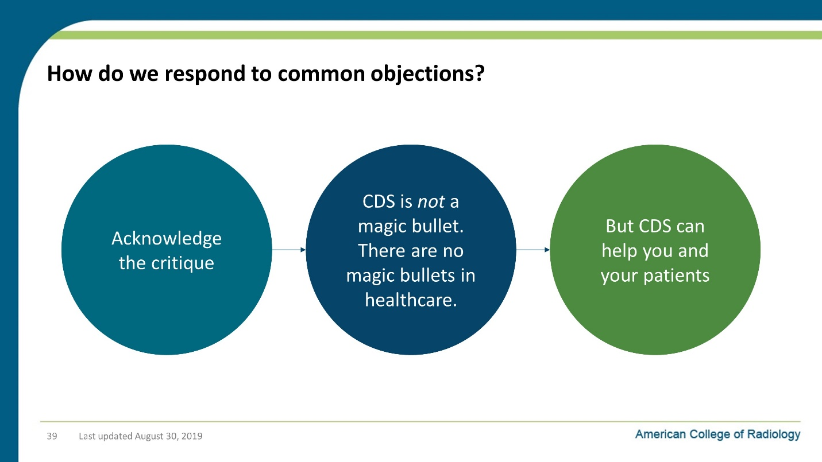

Notes on Slide 39:
So the response to this is actually pretty simple.
First, you can acknowledge the critique. While reasonable people can disagree, the critics to raise some reasonable points.
But rather than reply to those objections line by line, it might be more effective to say:
- CDS is not a magic bullet. There are no magic bullets in healthcare.
- But CDS can help you and your patients. The process for ordering images is broken and everyone knows it.

Slide 40: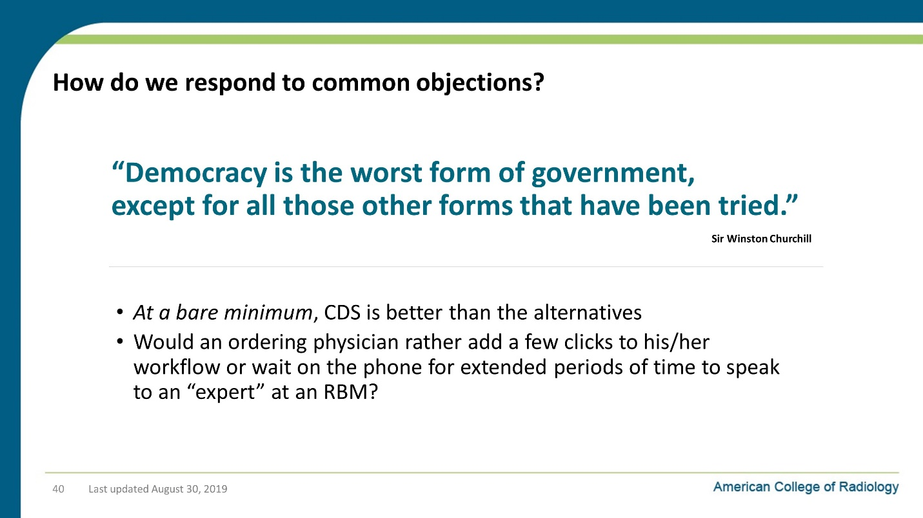

Notes on Slide 40:
- So we can add a few clicks to your EHR workflow, or you can start handling prior authorization calls for all of your Medicare patients.
- Because that’s where things were headed before the ACR stepped in to propose CDS as an alternative to prior authorization.
It’s sort of like the old expression, “Democracy is the worst form of government, except for all those other forms that have been tried.”

Slide 41: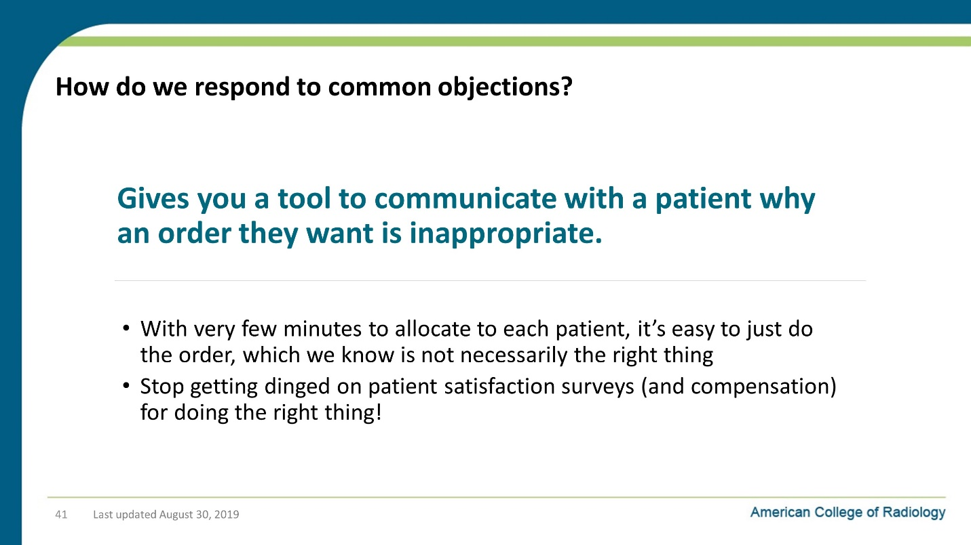

Notes on Slide 41:
Also, we all have patients who really want a scan, even though you know there is no benefit to it, and maybe even some hard.
CDS gives you a tool to communicate with a patient why an order they want is inappropriate.
And maybe then you can stop getting dinged on patient satisfaction survey (and compensation) for doing the right thing!

Slide 42: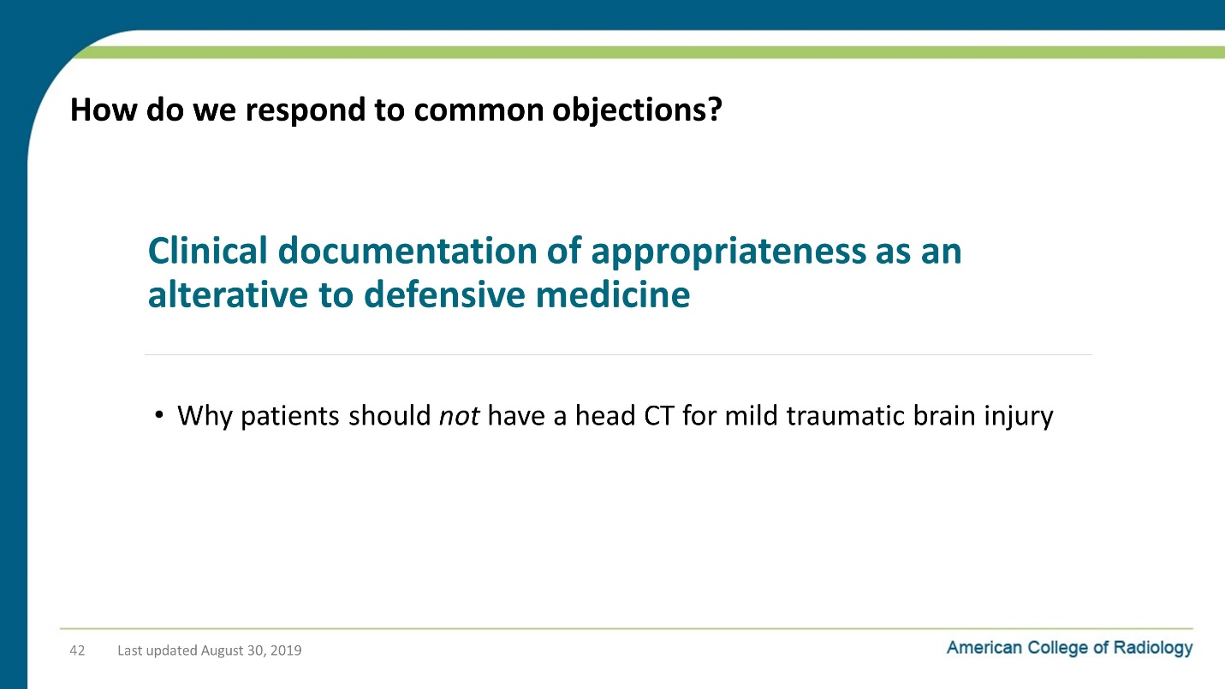

Notes on Slide 42:
Also, clinical documentation of appropriateness is an alternative to defensive medicine.
If the EHR documents that it advised you not to order the head CT for the patient who bumped their head but has no symptoms, then that’s something that can help you in a malpractice suit.
And I should note that there is an exception to consulting CDS in the case of an emergent case, so CDS will not stand in the way of physician judgement in situation where there is literally no time to waste in diagnosis.

Slide 43: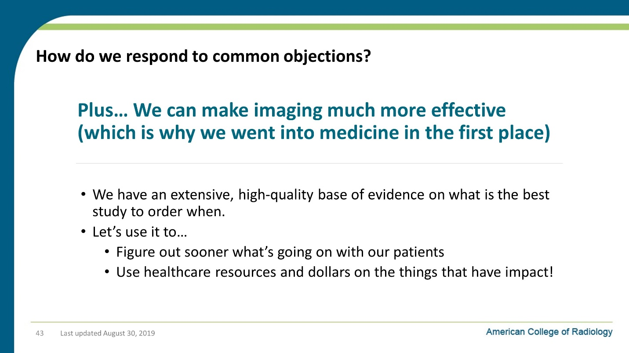

Notes on Slide 43:
We have an extensive, high-quality base of evidence on what is the best study to order when… let’s use it to…
Then we can figure out what’s going on with our patients sooner and help them get better.
Isn’t that why we all went into medicine in the first place?

Slide 44: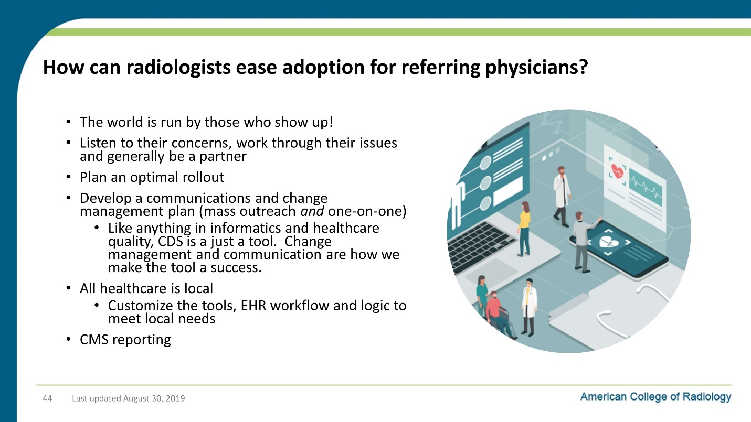

Notes on Slide 44:
So how can we step up?
How can radiologists can ease adoption for referring physicians?
The answer isn’t rocket science. It just takes good, patient work.
Basically, the world is run by those who show up!
Listen to their concerns, work through their issues and generally be a partner!
Plan optimal rollout
Communications plan (mass and one-on-one)
All healthcare is local!
Customize the tools, EHR workflow and logic to meet local needs
Help with CMS reporting to make sure it goes smoothly

Slide 45: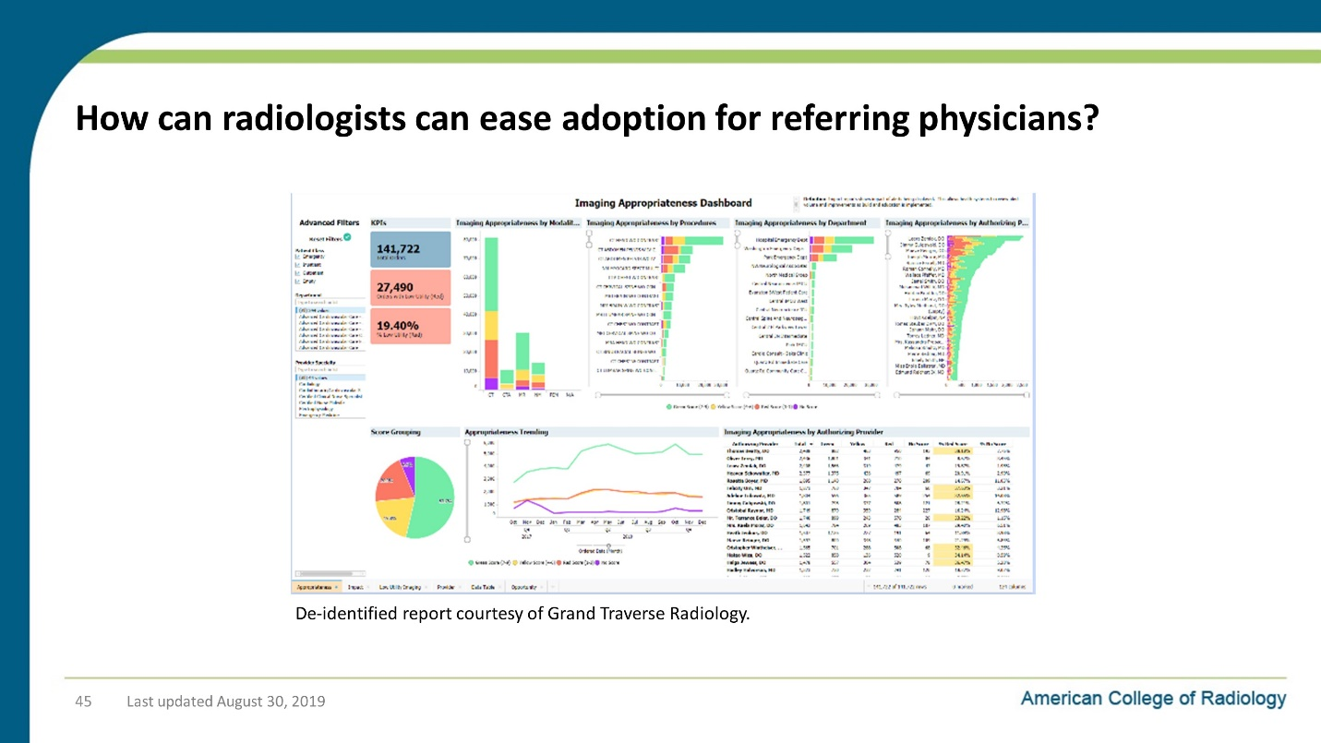

Notes on Slide 45:
This is an example of a QI dashboard that a radiology practice put together to help them work with ordering providers to improve the appropriateness of their imaging.

Slide 46: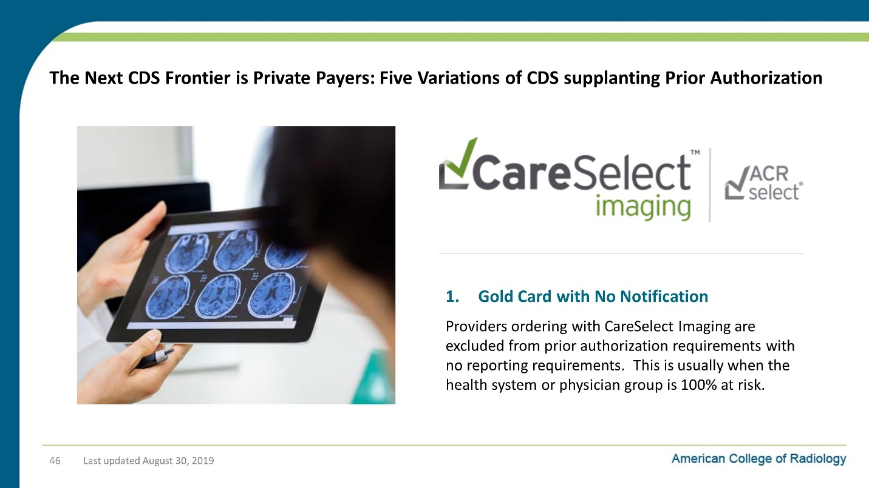

Notes on Slide 46:
So after Medicare, the next big frontier for CDS is when providers and other payers like Blue Cross, Aetna and state Medicaid programs enter into arrangements where CDS can supplant prior authorization as the way to control utilization and improve healthcare outcomes.
There’s a number of different flavors of these collaborations that we’ve seen.
The first version of this is “Gold Card with no Notification” for situations when the providers are 100% at risk. In those cases, the payers basically know the providers are using CDS and trust them to do the right thing with appropriate imaging b/c it’s clearly in their financial self interest.
The common denominator between the next 4 variants is that the providers regularly share data with the payors on how its going so that they payers see demonstrated ROI and value from the use of CDS. And that sharing of data also puts a very healthy accountability on the providers that drives behaviors that help our patients in the end by aligning incentives to ensure appropriate imaging for our patients.

Slide 47: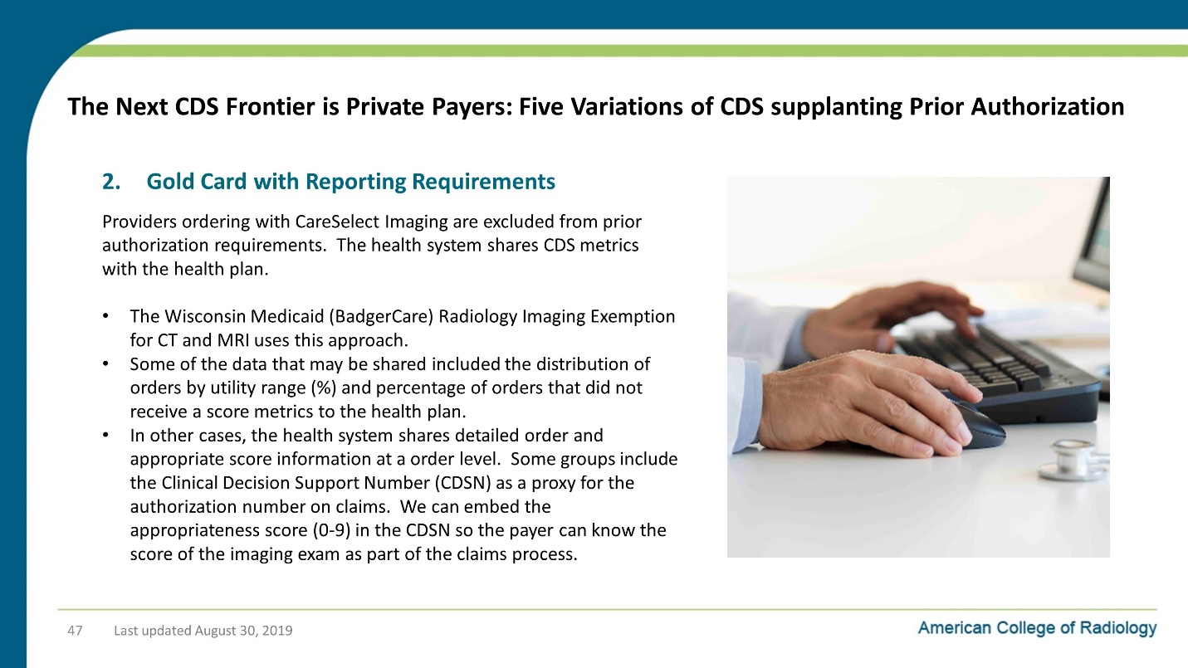

Notes on Slide 47:
The second variant is “ Gold Card with Reporting Requirements.” In this case, as long as a provider consults CDS, they can bypass any prior authorization. They do share data about this with the payers.

Slide 48: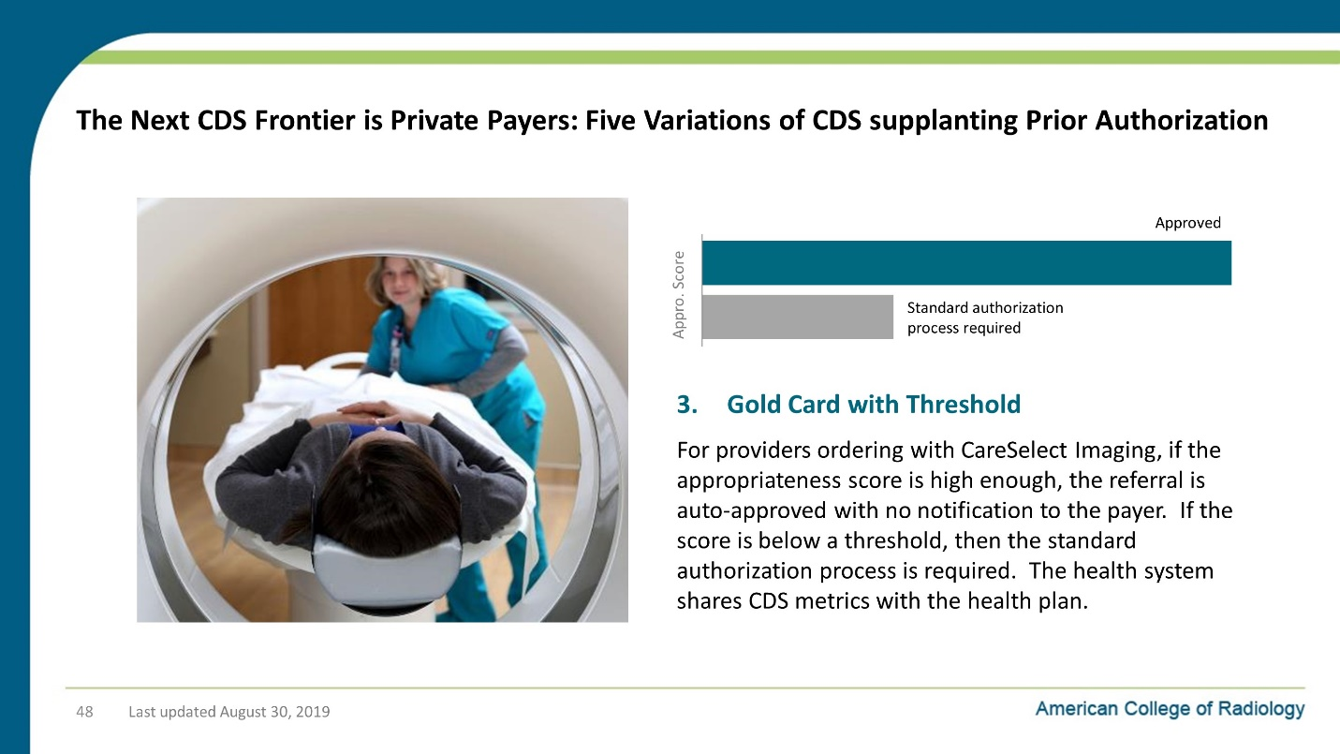

Notes on Slide 48:
The third variant is “Gold card with threshold” where orders are auto approved if the CDS indicates that the exam meets a certain level of approiratness. If the order does not, then the order enters the Prior Authorization process.

Slide 49: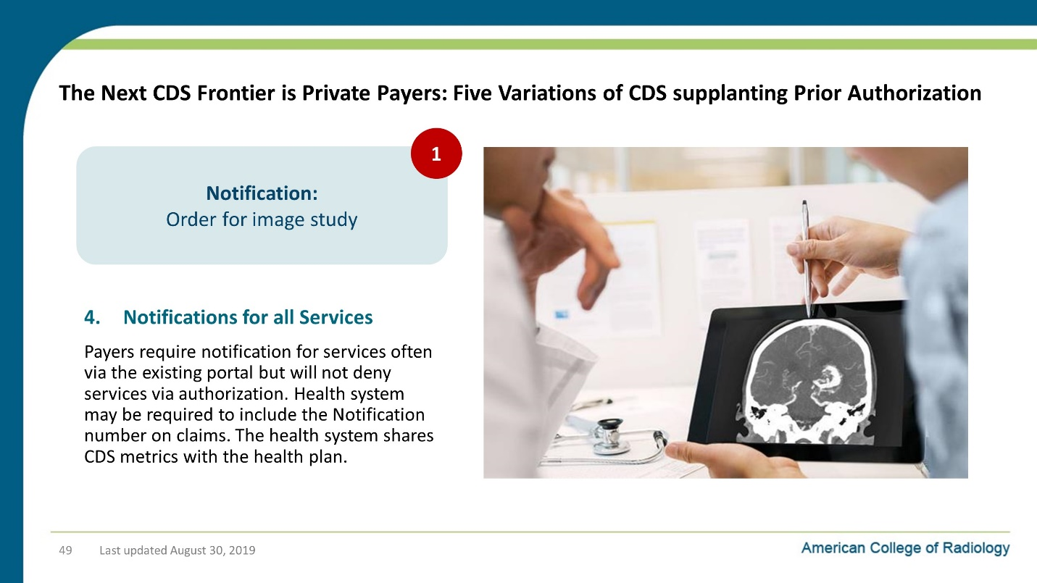

Notes on Slide 49:
In the fourth variant, the provider still has to notify the provider that they are issuing and order for an imaging study, but the provide will let that sail through as long as the CDS consult is properly documented.

Slide 50: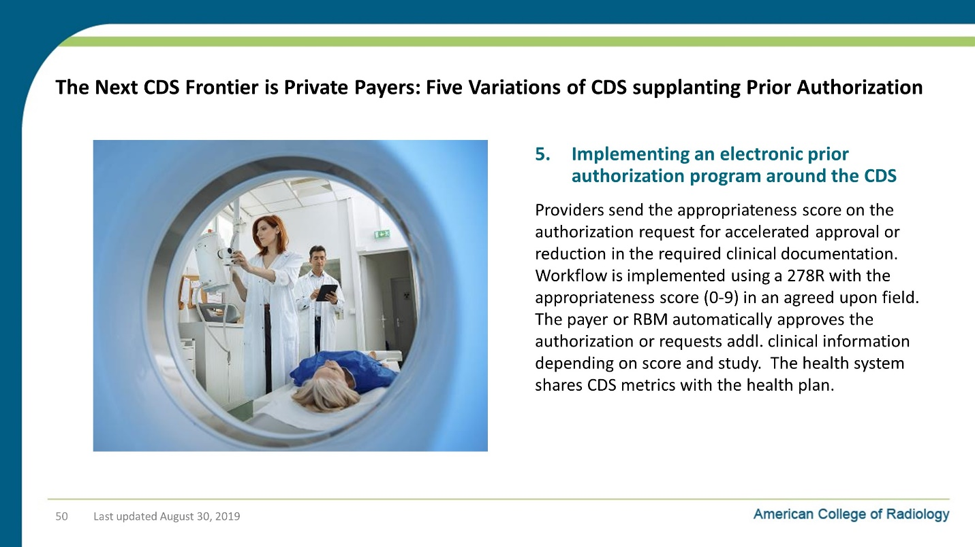

Notes on Slide 50:
In the 5th and final version, CDS basically becomes part of the prior authorization process, but a CDS order that is properly done should be auto approved or the back-and-forth process to get follow-up information is streamlined so that it takes less effort on the part of the provider and the approval happens on a much faster timeline than traditional prior authorization.

Slide 51: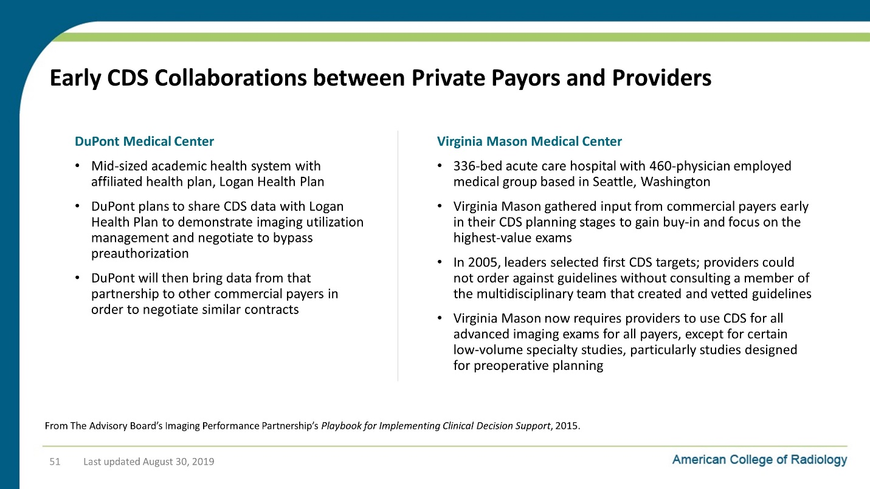

Notes on Slide 51:
These are two early case studies of CDS collaborations between providers and payers: DuPont Medical Center and Virginia Mason medical Center
One common denominator for both of these is that there was a pilot project with a single payer, and once they built up data showing the ROI of CDS, they were able negotiate similar deals with additional private payers.

Slide 52: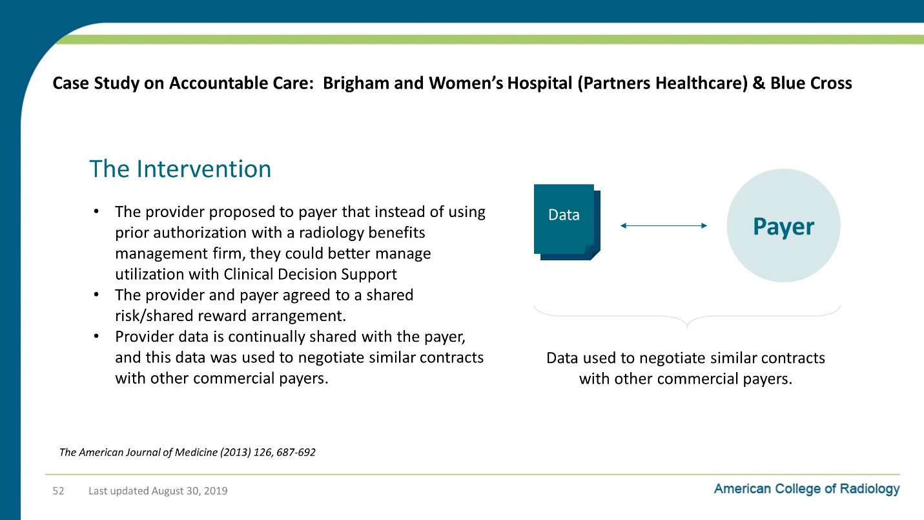

Notes on Slide 52:
In Massachusetts, Brigham and Women’s Hospital had been approached by Blue Cross about implementing prior authorization for imaging. They already had CDS in place at the time and were able to shift the conversation to a CDS-based solution, which has worked very well.
Brigham and Women’s even shares some of the savings not just with Blue Cross, but also with the ordering physicians. So it’s a win-win-win for everyone involved.

Slide 53: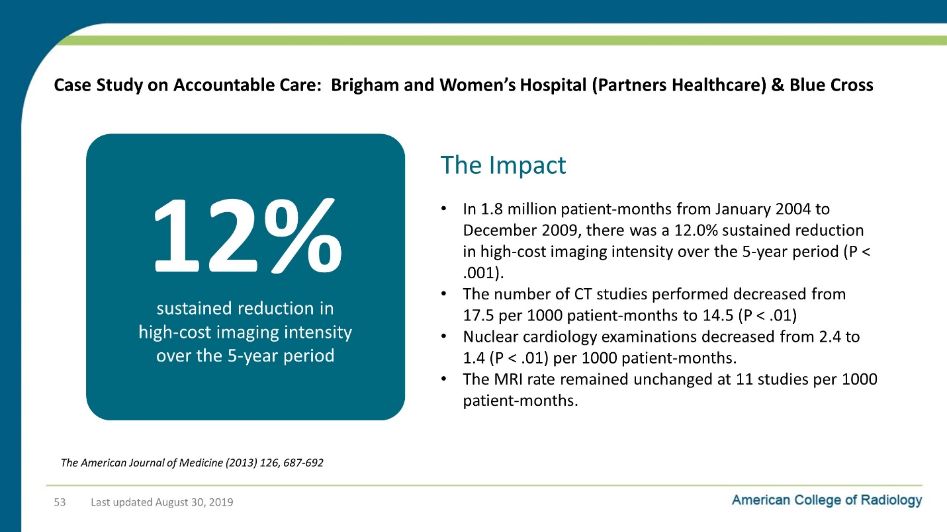

Notes on Slide 53:
What they found over a 5 year period is that there was a 12% sustained reduction in high-cost imaging intensity over the 5-year period.

Slide 54: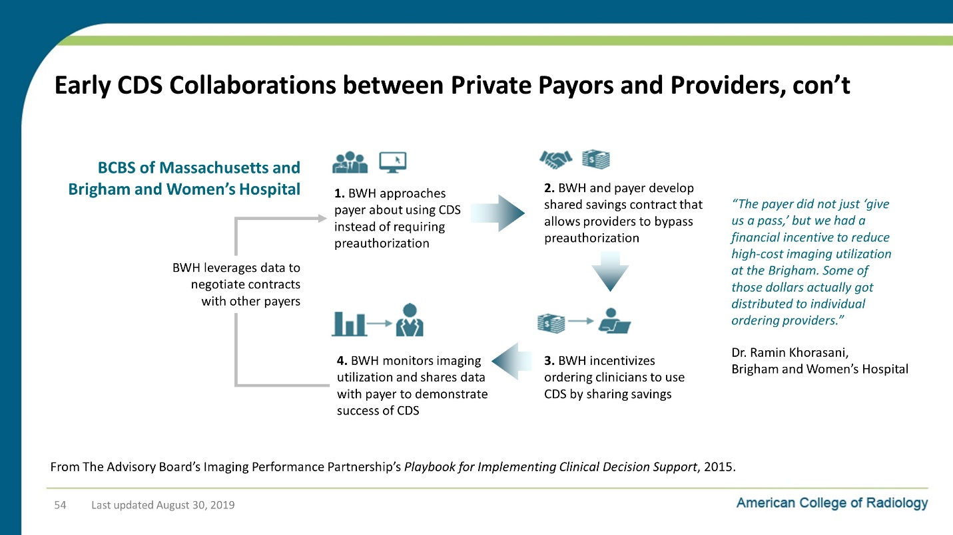

Notes on Slide 54:
We don’t need to look at this now, but the Advisory Board put together this great diagram to illustrate how this all worked.

Slide 55: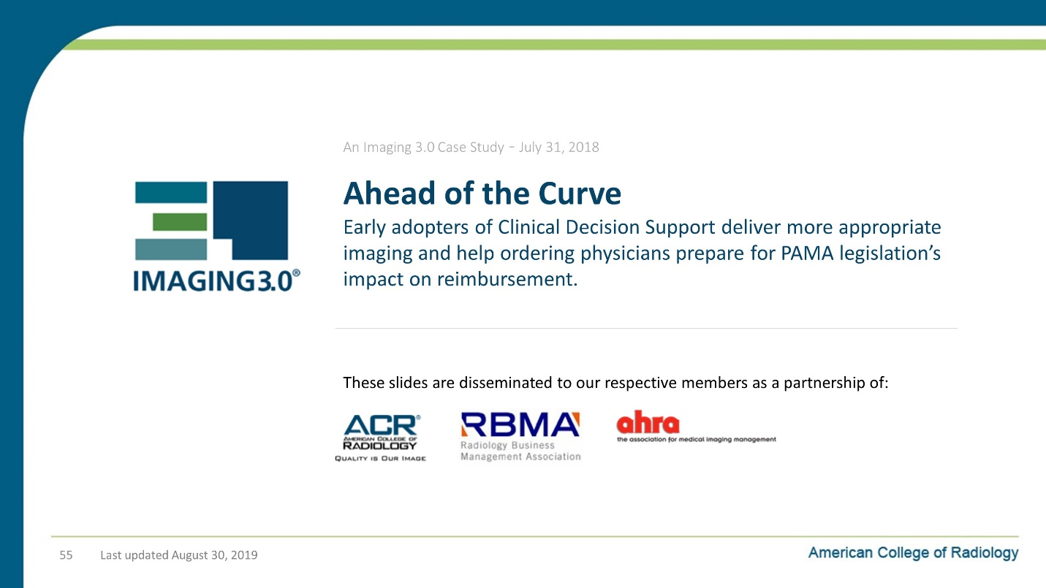

Notes on Slide 55:
So here’s a case study of a successful CDS implementation.

Slide 56: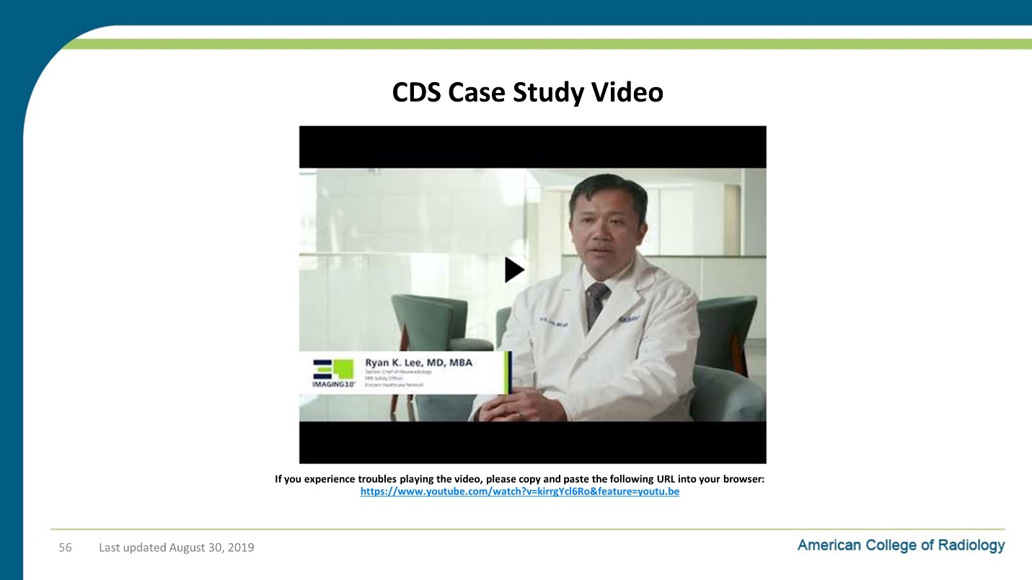

Notes on Slide 56:
Watch the video

Slide 57: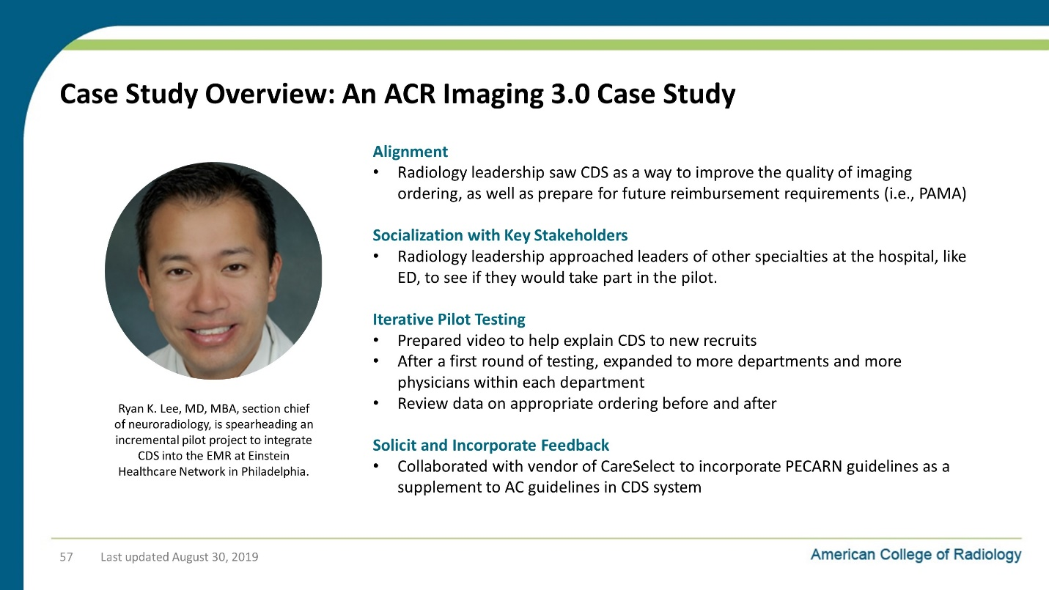

Notes on Slide 57:
Slide 58: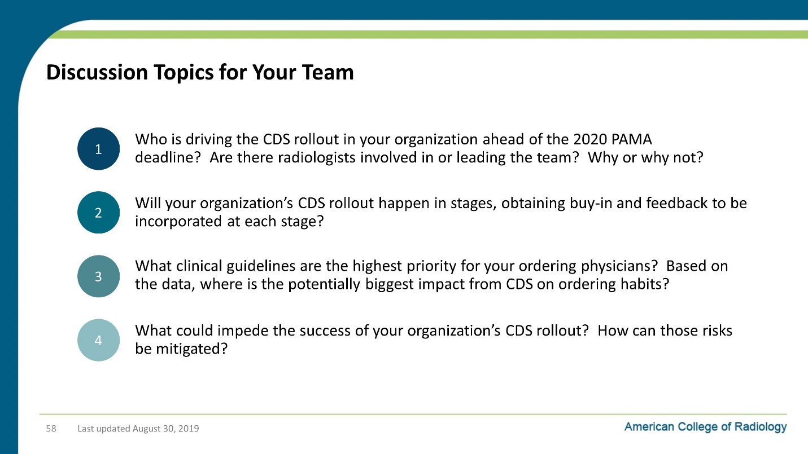

Notes on Slide 58:
Slide 59: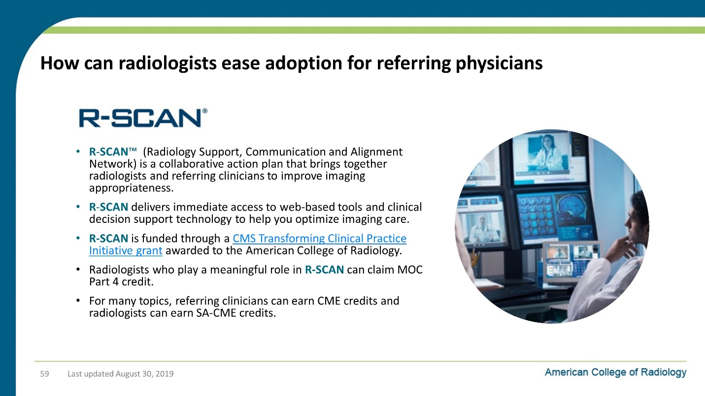

Notes on Slide 59:
Slide 60: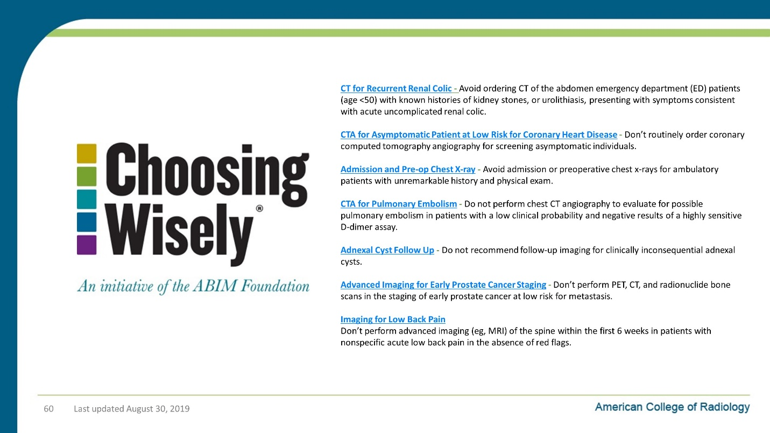

Notes on Slide 60:
R-SCAN has content based on a number of Choosing Wisely topics related to appropriate imaging.

Slide 61: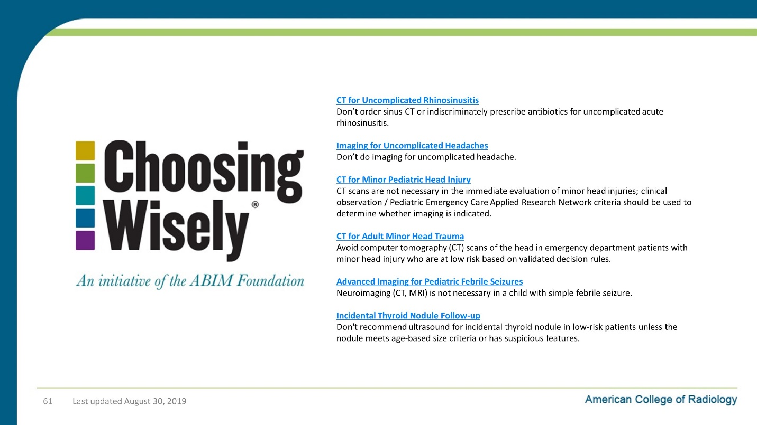

Notes on Slide 61:
Slide 62: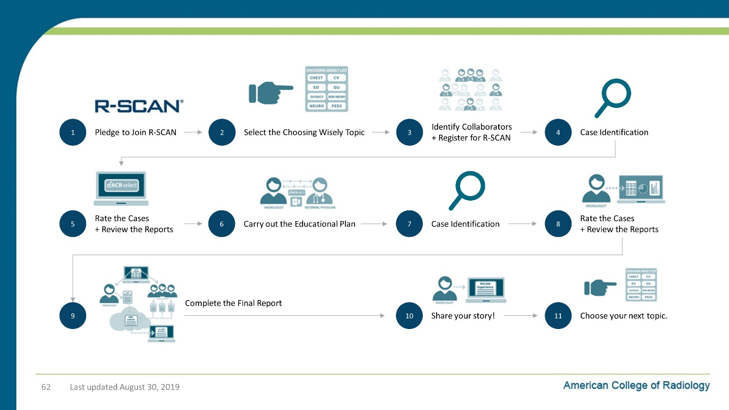

Notes on Slide 62:
Slide 63: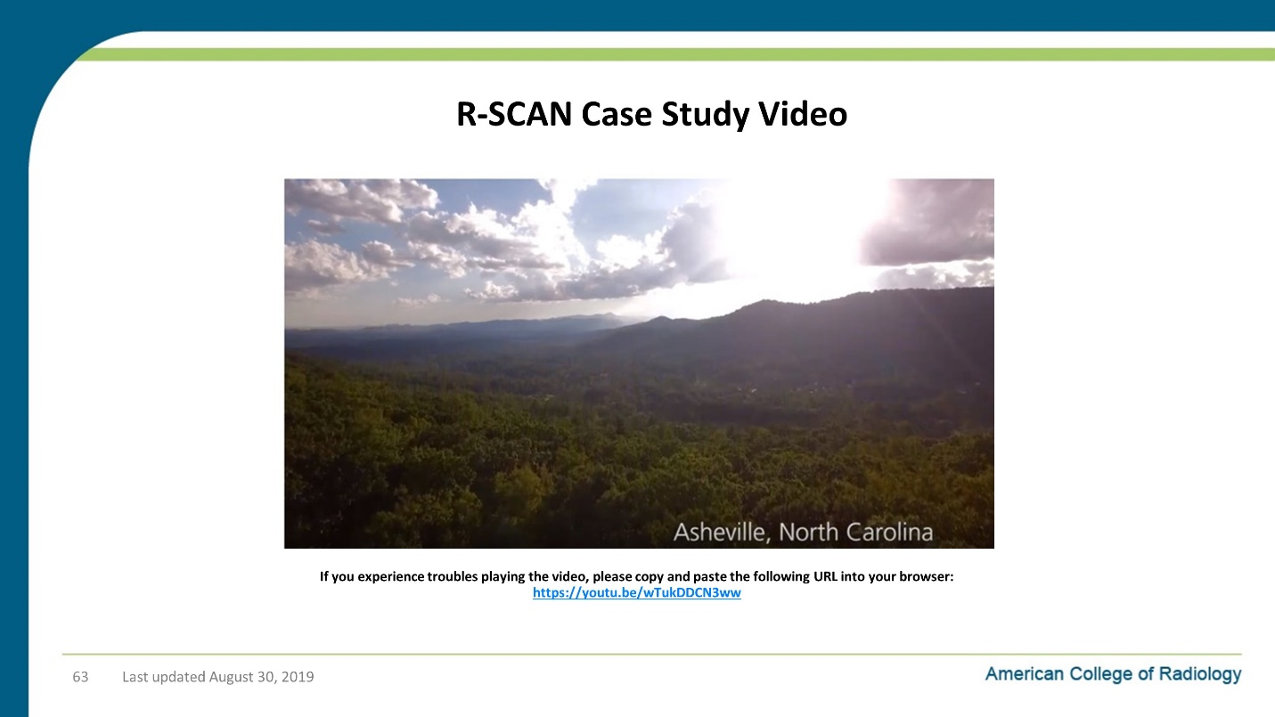

Notes on Slide 63:
Slide 64: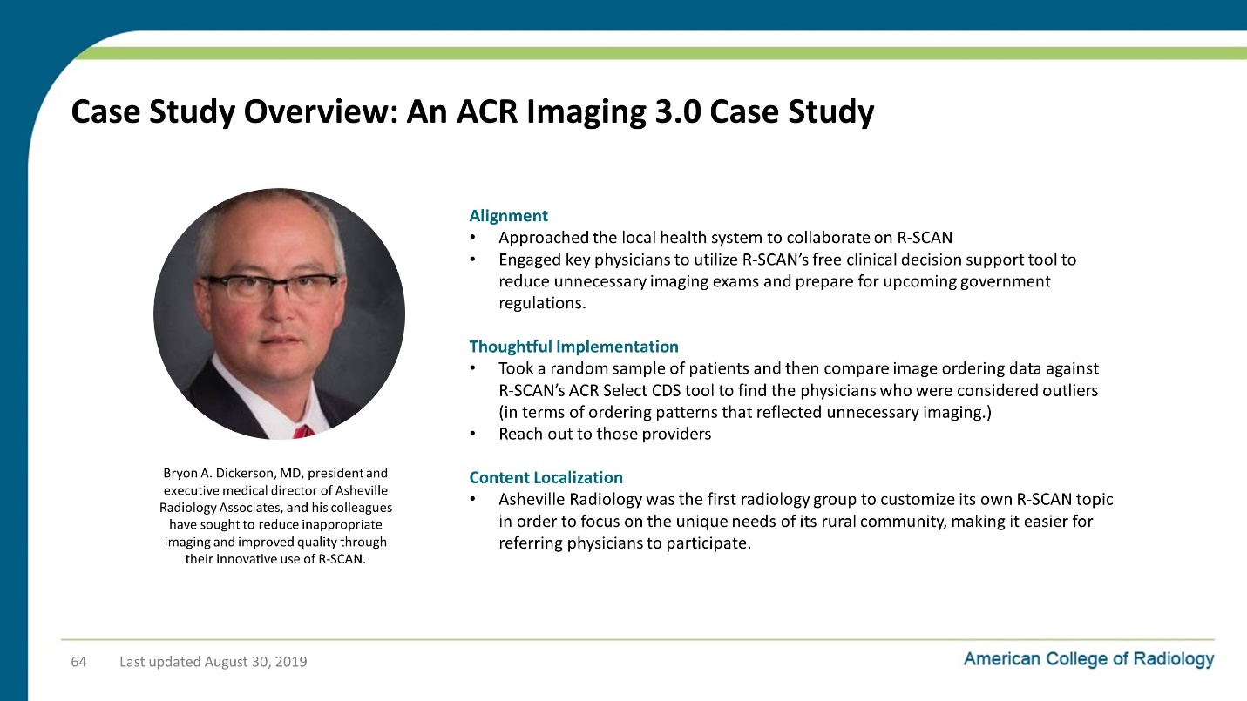

Notes on Slide 64:
Slide 65: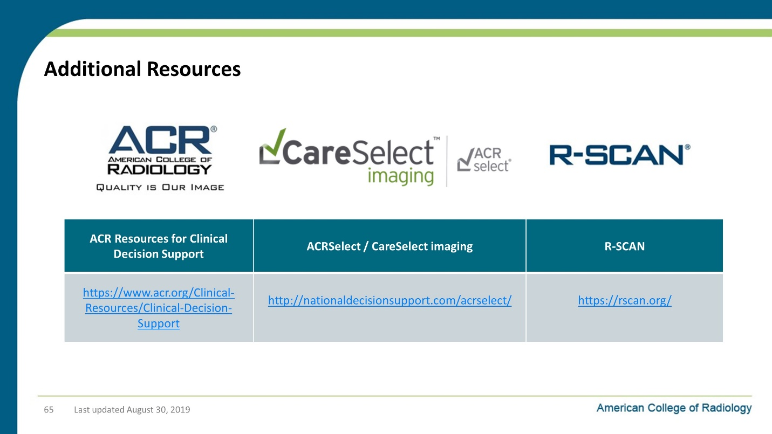

Notes on Slide 65:
Here are links to additional resources from the ACR on the topics we’ve discussed today.

Slide 66:

Notes on Slide 66:

