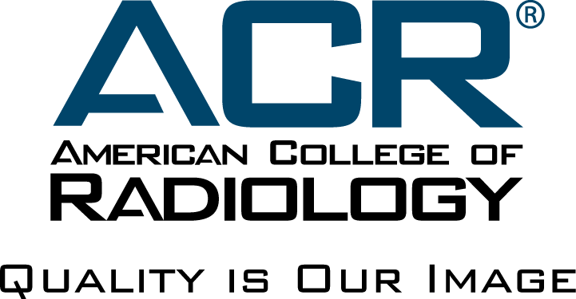
APPLICATION
AMERICAN COLLEGE OF RADIOLOGY
Richard L. Morin, PhD Fellowship in
Medical Physics

- General Information
- Name:
- Preferred Mail Address
- City State ZIP
- Phone:
- E-mail:
- Name of Training Program:
- Subspecialty (if applicable):
- Institution:
- Name of Program Director:
- Department Chair:
- Current Year in Residency:
- Expected Year of Residency Completion
- Please identify two current top areas of interest
- Area 1:
- Area 2:
- Please choose at least one modality of interest for accreditation:

- What prior experiences (activities, courses, and jobs) have best prepared you for this fellowship?

- Why are you applying for this fellowship and what do you hope to gain from it?

- Please include a copy of your CV.
- Please have two letters of recommendation submitted to dgress@acr.org, addressed to Mahadevappa Mahesh, MS, PhD, FACR, FAAPM, Chair of ACR Commission on Medical Physics.
- Please have your program director or department chair write a letter confirming support of the extracurricular requirements of the Fellowship. This confirmation may be included in a letter of recommendation or attached independently in your application materials.
Email: dgress@acr.org
Mail: Richard L. Morin, PhD, Fellowship in Medical Physics
Department of Quality and Safety -- Dustin Gress
American College of Radiology
1891 Preston White Drive
Reston, VA 20191-4397

